ANSI MH10.8.7 –
(revision of
ANSI MH10.8.7 – 2006)

Notice
This is a draft document and thus, is dynamic in nature. It does not reflect a consensus of the MH10.8.7 Committee and it may be changed or modified. Neither ANSI nor the MH10.8.7 Committee makes any representation or warranty, express of implied, with respect to the sufficiency, accuracy or utility of the information or opinion contained or reflected in the material utilized. ANSI and the MH10.8.7 Committee further expressly advise that any use of or reliance upon the material in question is at your risk and neither ANSI nor the MH10.8.7 Committee shall be liable for any damage or injury, of whatever nature, incurred by any person arising out of any utilization of the material. It is possible that this material will at some future date be included in a copyrighted work by ANSI.

American National Standard
for Material Handling -
Labeling and Direct Product Marking with
Linear Bar Code and Two-Dimensional Symbols



Material Handling Industry
8720 Red Oak Blvd., Suite 201
Charlotte, NC 28217-3992
Printed: XX/XXXX

American  National  Standard | This is a draft proposed American National Standard (ANS) of the accredited standards committee (ASC) MH 10. As such, this is not a completed standard. The MH 10/SC 8 Committee may modify this document as a result of comments received during public review and its approval as a standard.  Permission is granted to members of MH 10, its subcommittees, and their associated work groups to reproduce this document for the purposes of MH 10 standardization activities without further permission, provided this notice is included. All other rights are reserved. Any commercial or for-profit duplication is strictly prohibited.  Approval of an ANS requires verification by the American National Standards Institute (ANSI) that the requirements for due process, consensus, and other criteria for approval have been met by the standards developer. Consensus is established when, in the judgment of the ANSI Board of Standards Review, substantial agreement has been reached by directly and materially affected interests. Substantial agreement means much more than a simple majority, but not necessarily unanimity. Consensus requires that all views and objections be considered and that effort be made toward their resolution.  The use of an ANS is voluntary. Existence of the standard does not in any respect preclude anyone, whether he or she has approved the standards or not, from manufacturing, marketing, purchasing, or using items, processes, or procedures not confirming to the standards.  ANSI does not develop standards and in no circumstances will give interpretation on any ANS in the name of the ANSI. Address requests for interpretations to the secretariat or sponsor whose name appears on the title page of this standard.  CAUTION NOTICE: This ANS may be revised or withdrawn at any time. The ANSI procedures require periodic action to reaffirm, revise, or withdraw this standard. Purchasers of ANSs may receive current information on all standards by calling or writing the ANSI.

Published by:

MH10, Unit-Loads & Transport-Packages,
ANSI and Accredited Standards Committee
Secretariat: Material Handling Industry
8720 Red Oak Blvd., Suite 201, Charlotte, NC 28217-3992

Copyright © 2006, 2011 by Material Handling Industry
All rights reserved.

No part of this publication may be reproduced in any
form, in an electronic retrieval system or otherwise,
without prior written permission of the publisher

Printed in the United States of America

ANSI MH10.8.7 –
(revision of ANSI MH10.8.7 - 2006)

American National Standard
for Material Handling –
Labeling and Direct Product Marking with
Linear Bar Code and Two-Dimensional Symbols

Secretariat
Material Handling Industry

Approved Month Day, XXXX
American National Standards Institute, Inc.

Committee Ballet Results and Action Taken MMM DD, YYYY

Company | Clause/  subclause  (e.g. 3.1) | Para-graph/  Figure/  Table  (e.g.  Table 1) | Type of com-ment¹  (e.g. ed) | Comments: Justification for change | Proposed change or language | Disposition by the committee  on each comment submitted

Table of Contents

Foreword ii
1 Scope 2
2 References 2
2.1 Normative References 2
2.2 Reference Acquisition 2
3 Definitions 2
4 Requirements 2
4.1 Identification 2
4.1.1 Unique Item Identification 2
4.1.2 Lot or Batch Identification 2
4.2 Data Format Common Requirements 2
4.2.1 General Format 2
4.2.2 Mandatory Data Fields 2
4.2.3 Optional data fields 2
4.2.4 Syntax 2
4.3 General Layout and Location 2
4.3.1 Layout 2
4.3.2 Location 2
4.3.3 Linear Bar Code Titles 2
4.3.4 Human readable interpretation 2
4.4 Symbol Requirements 2
4.4.1 Symbology Recommendations 2
4.4.2 Linear Bar Code Symbol Requirements 2
4.4.3 Two-Dimensional Symbol Requirements 2
4.4.4 Composite Symbol Requirements 2
5 Bibliography (Informative) 2
Annex A 2
A.1 General 2
A.2 Requirements 2
A.2.1 Label Thickness 2
A.2.2 Nature of Adhesive 2
A.2.3 Adhesion Strength 2
A.2.4 Label Requirements after Conditioning and Printed Circuit Board Processing 2
A.2.5 Abrasion 2
A.3 Method of Test 2
A.3.1 Label Thickness 2
A.3.2 Nature of Adhesive 2
A.3.3 Adhesive Strength 2
A.3.4 Additional Label Conditioning Tests for Labels or Marks Required to Withstand Printed Circuit Board Processes 2
A.3.5 Abrasion test 2
Annex B 2
Annex C 2
Annex D 2
Annex E 2
Annex F 2
F.1 Systems Where a Single Option is Intended to be Scanned 2
F.2 Systems Where Multiple Options are Intended to be Scanned 2
F.3 Migration Choices 2
F.3.1 Systems Considerations 2
F.3.2 Equipment Considerations 2
F.3.3 Recommended Actions to Manage Migration 2
Annex G 2
G.1 About the DUNS Number 2
G.2 Using the DUNS Number in Bar Codes 2
G.3 Using the DUNS Number in 2D Symbols 2

Foreword
(This Foreword is not part of American National Standard MH10.8.7

This American National Standard was prepared by Subcommittee 8 of the MH10 (Unit-Loads and Transport-Packages) ANSI Accredited Standards Committee (ASC). This standard was established in response to a growing need for a comprehensive product marking standard.

This standard was developed using Industry Specifications as primary references.

Committee approval of this standard does not necessarily imply that all committee or subcommittee members voted for its approval. At the time of MH10.8.7 approval, MH10 committee membership consisted of the following organizations:

AIM USA
American Trucking Associations
American Wood Packaging Association
APA – The Engineered Wood Association
Association of American Railroads
Assn. of Professional Material Handling Consultants
ASTM
Automotive Industry Action Group
Comp TIA
Containerization & Intermodal Institute, Inc.
Department of Defense
Electronic Industries Alliance
Fibre Box Association
Flexible Intermediate Bulk Container Assoc.
General Services Admin./Federal Supply Service
Glass Packaging Institute
Graphic Communications Association
GS1
Industry Bar Code Alliance
Institute of Packaging Professionals
International Cargo Handling Coordination Assoc.
ISTA
Material Handling & Management Society
Material Handling Industry of America
National American Wholesale Grocer's Association
National Wooden Pallet & Container Association
Paper Shipping Sack Manufacturers Association
Rack Manufacturers Institute
Soap & Detergent Association
Steel Shipping Container Institute
Textile Bag Manufacturers

United Fresh Fruit & Vegetable Association
US Dept. of Agriculture
US Forest Products Laboratory

Add
Q.E.D. Systems
Intermec Technologies
United Parcel Service
USAF
(others . . . )

Scope
This American National standard:
- Defines minimum requirements for identifying items;
- Provides guidelines for item marking with machine-readable symbols;
- Covers both labels and direct marking of items;
- Includes testing procedures for label adhesive characteristics and mark durability;
- Provides guidance for the formatting on the label of data presented in linear bar code, two-dimensional symbol or human readable form;
- Is intended for applications which include, but are not limited to, support of systems that automate the control of items during the processes of:
  - production,
  - inventory,
  - distribution,
  - field service,
  - point of sale and
  - repair.
- Is intended to include, but it is not limited to, multiple industries including:
  - automotive,
  - aerospace,
  - chemical,
  - consumer items,
  - electronics,
  - health care,
  - marine,
  - rail, and
  - telecommunications.

The location and application method of the marking are not defined herein. Before implementing this standard, suppliers and manufacturers should review and mutually agree on these details with their trading partners.

This standard does not supersede or replace any applicable safety or regulatory marking or labeling requirements. This standard is meant to satisfy the minimum product package requirements of numerous applications and industry groups. As such its applicability is to a wide range of industries, each of which may have specific implementation guidelines for this standard. This standard is to be applied in addition to any other mandated labeling requirements.

This document consists of four sections and a series of annexes to support this application.

Section 1 Defines the purpose of this standard.

Section 2 Lists references to support this standard.

Section 3 Refers to the definitions contained in Annex A.

Section 4 provides a common set of definitions and parameters for item marking in general.

In this document, the word "shall" indicates a requirement and the word "should" indicates a recommendation. This standard does not supersede or replace any applicable safety or regulatory marking or labeling requirements. This standard is meant to satisfy the minimum item marking requirements of numerous applications and industry groups. As such its applicability is to a wide range of industries, each of which may have specific implementation guidelines for this standard. This standard is to be applied in addition to any other mandated labeling direct marking requirements.

Before implementing this specification, suppliers and manufacturers should review and mutually agree on specific labeling and direct marking details with their trading partners. The labeling and direct marking requirement of this standard and other standards may be combined into one label or marking area or appear as separate labels or marking areas.

In this document the terms “part marking” and “item marking” are used interchangeably. Unless otherwise stated, this document will use the term “item marking” to describe both the labeling and direct part marking (DPM) of an item. Direct part marking includes but is not limited to altering (e.g., dot peen, laser etch, chemical etch) as well as additive type processes (e.g., ink jet, vacuum deposition)

The purpose of this standard is to establish the machine-readable (linear, two dimensional, and composite symbols) and human readable content for direct marking and labeling of items, parts, and components.

This standard provides a means for items, parts and components to be marked, and read in either fixtured or handheld scanning environments at any manufacturer’s facility and then read by customers purchasing items for subsequent manufacturing operations or for final end use. Intended applications include, but are not limited to supply chain applications, e.g., inventory, distribution, manufacturing, quality control, acquisition, transportation, supply, repair, and disposal.

The figures contained herein are illustrative and not necessarily to scale or to the quality requirements in this document.

References
The following referenced documents are indispensible for the application of this document. For dated references, only the edition cited applies. For undated references, the latest edition of the referenced document (including any amendments) applies.

Normative References

ISO/IEC 15415 Bar Code Symbol Print Quality Test Specification - Two Dimensional Symbols

ISO/IEC 15416 Bar Code Print Quality Test Specification - Linear symbols

ISO/IEC 15417 Bar Code Symbology - Specification Code 128

ISO/IEC 15418 GS1 Application Identifiers and ASC MH10 Data Identifiers

ISO/IEC 15420 Bar code Symbology Specification – EAN/UPC

ISO/IEC 15424 Information technology – Automatic identification and data capture techniques – Data Carrier Identifiers (including Symbology Identifiers)

ISO/IEC 15434 Syntax for High Capacity ADC Media

ISO/IEC 15438 Bar Code Symbology Specification - PDF417

ISO/IEC 15459-1 Information technology – Unique identifiers for item management – Part 1: Technical standard.

ISO/IEC 15459-2 Information technology – Unique identifiers for item management – Part 2: Procedural standard.

ISO/IEC 16022 Bar Code Symbology Specification - Data Matrix

ISO/IEC 16388 Bar Code Symbology - Specification Code 39

ISO/IEC 19762 Information Technology Automatic Identification and Data Capture Techniques - Harmonized Vocabulary Check existance prior to publishing

ISO/IEC 24720 Information technology, automatic identification and data capture techniques – Guidelines for direct part marking (DPM)

ISO/IEC 24723 Error: Reference source not found

ISO/IEC 24728 Information technology, automatic identification and data capture techniques – Bar code symbology specification - MicroPDF417

ISO/IEC 3166-1 Codes for the representation of names of countries and their
subdivisions, Part 1: Country Code

ANS HIBC 2, Health Industry Supplier Labeler Standard

ANS MH10.8.2 Data Application Identifier Standard

ANS ATIS-0300220 Telecommunications - Information Interchange - Coded Representation of the North American Telecommunication Industry Manufacturers, Suppliers, and Related Service Companies

ANS ATIS-0300213 Coded Identification of Equipment Entities of the North American Telecommunications System for Information Exchange

ASCII/ISO 646 Information Processing - ISO 7-Bit Coded Character Set for Information codes

ASTM D1000-93 Pressure-Sensitive Adhesive-Coated Tapes Used for Electrical and Electronic Applications

ASTM E29-93a Using Significant Digits in Test Data to Determine Conformance with Specifications

Dun & Bradstreet DUNS®Number

ESN Assignment Guidelines and Procedures

GS1 General Specifications, GS1 Brussels Belgium

Mobile Equipment Identifier (MEID) GHA (Global Hexadecimal Administrator) Assignment Guidelines and Procedures

NAMSA, ACodP-1(D), Chapter 2, Subsection 242-243, (NCAGE)

NASA-STD-6002 Applying Data Matrix Identification Symbols on Aerospace Parts

NASA-HDBK-6003 Application of Data Matrix Identification Symbols to Aerospace parts using Direct Part Marking Methods/Techniques
SAE AS 9132 Data Matrix (2D) Coding Quality Requirements for Parts Marking.

Reference Acquisition

International Symbology Specifications and AIM Inc.:
- 125 Warrendale-Bayne Road, Warrendale, PA 15086,(V): +1 724 934 4470, (F): +1 724 934 4495, (U): http://www.aimglobal.org/

American National Standards T1 and X3, and ASCII/ISO:
- American National Standards Institute (ANSI), 25 West 43rd Street, Fourth Floor, New York, NY 10036; Phone 212-642-4900; Internet http://www.ansi.org

ASC MH10.8 Data Application Identifier Work Group for requests for new data identifiers:
- ASCI MH10.8 Data Application Identifier Work Group chairperson at P.O. Box 2524, Cedar Rapids, IA 52406-2524; Phone 319-364-0212; Fax 319-365-8814;
Email: craig.harmon@qed.org

ASTM Standards
- ASTM, 100 Barr Harbor Drive, West Conshohocken, PA 19428-2959; Phone 610-832-9585; Fax 610-832-9555; Email service@astm.org; Web http://www.astm.org

CAGE Code
- Defense Logistics Service Center, Federal Center, 74 N. Washington, Battle Creek, MI 49017-3084

DUNS® Number
- Dun & Bradstreet Corporation, 103 JFK Parkway, Short Hills, NJ 07078; Phone 973-921-5500; Internet http://www.dnb.com.

ESN and MEID Guidelines and Procedures
- Telecommunications Industry Association (TIA), 2500 Wilson Blvd., Suite 300, Arlington, VA 22201, 703-907-7735, Web site: http://www.tiaonline.org/standards/resources/esn/

GS1 Standards & Specifications:
- Blue Tower, Avenue Louise, 326, BE 1050 Brussels, Belgium, (V):+32 2 788 7800, (F): +32 2 788 7899, (U): http://www.gs1.org/
- GS1 US, Princeton Pike Corporate Center, 1009 Lenox Drive, Suite 202, Lawrenceville, NJ 08648, (V): +1 609 620 0200, (F): +1 609 620 1200,
(U): http://www.gs1us.org

CEA Standards and ANSI Standards:
- Global Engineering Documents, World Headquarters, 15 Inverness Way East, Englewood, CO USA 80112-5776; Phone 800-854-7179; Fax 303-397-2740; Internet http://global.ihs.com; Email global@ihs.com

MH10 Secretariat:
- MH10 Secretariat, The Material Handling Industry, 8720 Red Oak Blvd., Suite 201, Charlotte, NC 28217-3992; Phone 704-522-8644

Telcordia Technologies Generic Requirements (GR-383-CORE and GR-485-CORE)
- Telcordia Technologies, Inc., Customer Service, 1 Telcordia Drive, Room RRC 6G-141, Piscataway, NJ 08854-4157. Telephone: (800) 521-2673 or (732) 699-5800, (732) 336-2559 (Fax), Web site: www.commonlanguage.com

Definitions
For the purposes of this document, the terms and definitions given in ISO/IEC 19762 as well as the following apply.

ANSI (abbreviation for “American National Standards Institute”)
A non-governmental organization responsible for the coordination of voluntary national (United States) standards. ANSI, 25 West 43rd Street, New York, NY 10036, Telephone: (212) 642-4900 Telefax: (212) 302-1286
ASC MH 10
An ANSI accredited committee responsible for the development of American national standards on unit-load & transport-package sizes, package testing standard, definitions & terminology, standardization of unit-load height, sacks & multi-wall bag standards, coding & labelling of unit-loads.
ASC MH 10/SC 8
An ANSI accredited committee responsible for the development of American national standards on the coding and labelling of transport packages and unit loads, product packaging, and radio frequency identification for returnable containers. ANSI/MH 10/SC 8 serves as the U.S. Technical Advisory Group (TAG) to ISO TC 122.
Cell
The smallest element of a two-dimensional matrix symbol.
CLEITM Code
A coding structure maintained by Telcordia that identifies communications equipment, in a concise, uniform feature-oriented language, describing product type, features, source document and associated drawings and vintages.
Components
For the purposes of this document parts (e.g., bare printed circuit board, integrated circuits, capacitor, diodes, switch, valve, spring, bearing, bracket, bolt, etc.) of a first level/modular assembly.
Data Element Separator
A specified character used to delimit discrete fields of data.
First Level/Modular Assembly
For the purposes of this document, a manufactured item (populated printed circuit board, hydraulic pump, starter, dashboard assembly, door assembly, etc.) made up of components.
Intrusive Marking
Any device designed to alter a material surface to form a human or machine readable symbol. This marking category includes, but is not limited to, devices that abrade, burn, corrode, cut, deform, dissolve, etch, melt, oxidize or vaporize a material surface. Intrusive marking methods laser etch, chemical etch, dot peen and micro-sandblast.
Item
A first level or higher assembly that is sold in a complete end-usable configuration.
Label
For the purposes of this document, an adhesive backed media capable of being marked with information in machine-readable and/or human-readable form. Both labels and direct marking methods are referred to in this standard under the term “label”.
Manufacturer
Actual producer or fabricator of an item; not necessarily the supplier in a transaction.
Non-Intrusive Marking
A method of forming markings by adding material to a surface. Non-intrusive marking methods include ink jet, laser bonding, liquid metal jet, silk screen, stencil and thin film deposition.
Product
A first level or higher assembly that is sold in a complete end-usable configuration.
Supplier
In a transaction, the party that produces, provides, or furnishes an item or service.
Syntax
The way in which data is put together to form messages. Syntax also includes rules governing the use of appropriate identifiers, delimiters, separator character(s), and other non-data characters within the message. Syntax is the equivalent to grammar in spoken language.

Requirements

Identification

Enterprises may choose to assign uniqueness to items at the individual or group level.

Unique Item Identification

Items may be assigned a unique item identification code to each instance of the item, i.e., serialization. Serial numbers shall be either unique within an enterprise ID or unique within part number and enterprise ID. Serial numbers should be unique within enterprise ID. When using unique identification, the encoded symbol shall contain only one Enterprise identifier, serial number and/or original part number to avoid confusion and ensure uniqueness.

Lot or Batch Identification

Items can have group uniqueness applied by an enterprise. Some items are assigned a group identification, e.g. lot or batch number.

Data Format Common Requirements

Those implementing this standard should refer to the guidelines for their particular industries. A partial list of industry guidelines can be found in Reference Bibliography.

General Format

This label will accommodate both mandatory and optional data fields. The maximum length of each discrete data field shall be 25 data characters unless otherwise specified. This character count is exclusive of overhead characters.

All data elements encoded in a machine-readable medium shall be preceded by the appropriate Data Identifier (DI) defined in ISO/IEC 15418 and ANS MH10.8.2 Data Identifier, or the appropriate Application Identifier (AI) defined in ISO/IEC 15418 and the GS1 General Specifications. The exceptions to this rule are the UPC-A, UPC-E, EAN-8, and EAN-13 symbologies.

The choice between GS1 Application Identifiers or Data Identifiers for any user will normally be determined in the applicable industry convention being followed.

Other industries developing item identification conventions should consider business practices, information requirements and systems capabilities of the trading partners in choosing between Data Identifiers and GS1 Application identifiers. The user may also consider the following guidelines:

Data Identifiers (DIs):

The descriptions in the Data Identifier list are general in nature and are used in industrial and international applications. Specific application guidelines provide the detailed definition used amongst trading partners.

The full list of registered Data Identifiers (DIs) and the full specification for their use are found in the American National Standard MH10.8.2.

DIs may be used with any alphanumeric data carrier and are designed to ensure cross-industry commonality of data identifiers used in automatic identification technologies.

DIs have a format of one alphabetic character alone, or one alphabetic character prefixed by one, two or three numeric characters.

GS1 Application identifiers (AIs):

The definitions of the GS1 Application identifiers (AIs) are supported by application guidelines. The GS1 AIs, and associated guidelines, have been designed for international and multi-sectorial trading purposes.

The GS1 item identification system and related encodation standard are complemented by the GS1 maintained Application Identifiers, hereafter referred to as “GS1 Application Identifiers” (GS1 AIs). This standard comprises two principal elements which are the key to any encoding system: the data content and the data carrier.

The use of GS1 AIs is subject to the rules established by GS1.

GS1 AIs identify generic and simple data fields for use in cross sectorial and international supply chain applications. The GS1 General Specifications provide rules for the definition, format and structure of the data fields.

Each GS1 AI consists of two or more characters. The first two digits of the AI determine the length of the AI. A list of two digit codes indicating the predefined length of existing and future AIs and their data fields is contained within the GS1 General Specifications.

The Application Identifier (90) indicates that the data field contains any information mutually agreed between trading partners. It may also be used to incorporate data preceded by ANS MH10 Data Identifiers. (GS1 General Speicifications clause 3.10.1, [2011]). For the purpose of this standard, Application Identifier 90 will be used with MH10.8.2 Data Identifiers.

Organization Inclusion in Coding

It is recommended that data structures used to identify items or the traceability of items include identification of the organization providing the coding as well as the specific coding structure.

In the GS1 General Specifications this coding structure is the GS1 Company Prefix portion of the GTIN (Global Trade Item Number).

When using Data Identifiers this coding structure uses the Issuing Agency Code (IAC) established in ISO/IEC 15459-1 (Information technology – Unique identifiers for item management – Part 1: Technical standard) and the Company Identification Number (CIN) assigned by the issuing agency.

Mandatory Data Fields

Mandatory data fields are required as listed in Table 4-1: Item Identification Code Type.

Item Identification Type | Mandatory Fields
1. Commodity | Item identification code (example nails)
2. Non-traceable | Enterprise Identification code  Item identification code
3. Group Traceability | Enterprise Identification code,  Item identification code  Unique Lot or batch traceability code
4. Unique Serialization within Item Identifcation Code | Enterprise Identification Code  Item Identification Code  Unique Item traceability code within item Identification Code
5. Unique Serialization within Enterprise | Enterprise Identification Code  Unique Item traceability code within Enterprise Identification Code
Table 4-1 Item Identification Code Type

Enterprise Identification Code and Item Identification Code may be combined in a single data field. See Section 4.2.2.2.

Enterprise identification code

The Enterprise Identification Code shall use formats contained in Table 4-2. The use of more than one Enterprise Identification Code is permitted on an item preceded by Data Identifier 20V. The choice of Enterprise Identification Code(s) should be mutually agreed upon between trading partners. The appropriate Data Identifier shall precede the enterprise identification when separate data fields are used to identify the supplier and the item identification.

Data Identifier | Data Field | Data characteristics  Type followed by the number of characters e.g., a#, n#, an#)* | Description
18V | Combined IAC/CIN | an3+an1..3+an3..13 | Combined IAC/CIN
12V | DUNS Number  Identifying  Manufacturer | an3+n9 | Entity (Manufacturer)  Identification assigned  by Dun and Bradstreet
17V | U.S. Department  of Defense (DoD)  CAGE Code/NAMSA NCAGE | an3+an5 | Entity identification assigned  by the U.S. Department of Defense and  other members of NATO AC 135
20V | Company Identification | an3+an1..3+  an3..13+”+”+an3 | Combined IAC/CIN and Party Qualifier Code (EDIFACT DE 3035)
21V | Supplier Identification | an3 +an...25 | Combined IAC/CIN followed by an internally assigned entity identification

Application Identifier | Data Field | Data characteristics  Type followed by the number of characters e.g., a#, n#, an#)* | Description
N/A | Part Number (Supplier/Item)  GTIN-12/ | n12  (See Annex E) | UPC-A, UPC-E Symbology (Combination of Supplier & Item Identification)
N/A | Part Number (Supplier/Item)  GTIN-13 | n13  (See Annex E) | EAN-13 Symbology (Combination of Supplier & Item Identification)
01 | Part Number (Supplier/Item)  GTIN-14 | n2+n14 | GTIN-14  Format with GS1-128 symbology  (Combination of Supplier and Item)
* Note -The characters before the first “+” symbol describe the format of the Data or Application Identifier. Note that the “+” symbols are not encoded in the data except for “+” in 20V.

Table 4-2 Data Identifiers and Application Identifiers used for Enterprise Identification

Group and Item Traceability Codes

The Traceability Code is assigned by the supplier to identify a unique item or group of entities (e.g., lot, batch, date code, revision level or serial number). The Data Identifiers or Application Identifiers shown in Table 4-3 represent a partial list of the ASC MH10 Data Identifiers and GS1 Application Identifiers that may be applicable to traceability codes.

The traceability data field is assigned by the manufacturer or supplier. The maximum length of a single Traceability data field shall be 20 characters, which excludes the associated Data Identifier or Application Identifier.

Data Identifier | Data Field | Data characteristics  Type followed by the number of characters e.g., a#, n#, an#)* | Description
S | Serial No. | an1+an...20 | Serial number assigned by the supplier to an entity for its lifetime
18S | Serial No within CAGE/NCAGE Code | an3+an...20 | Serial number assigned by the CAGE/NCAGE Code holder that is unique within the CAGE/NCAGE Code
20S | Customer Assigned Serial No. | an3+an...20 | Serial number assigned by the customer to an entity for its lifetime
25S | Globaly Unique Serial Number | an3 +IAC/CIN+an...20 | Combined IAC/CIN and the serial number assigned by the CIN Holder
1T | Lot/Batch Number | an2+an...20 | Lot/Batch Number defined by the manufacturer
25T | Golbaly Unique Lot/Batch Number | an3 +IAC/CIN+an...20 | Combined IAC/CIN and enterprise identification and lot or batch Number assigned by the CIN Holder
+$ | HIBCC Lot/Batch Number | a2+an..15 | Options of concatenated lot or batch combinations with item data are specified with ANSI/HIBC 2

Application Identifier | Data Field | Data characteristics  Type followed by the number of characters e.g., a#, n#, an#)* | Description
10 | Batch/lot number | n2+an...20 | Traceability code defined by the manufacturer
11 | Production Date | n2+n6** | Production Date
21 | Serial Number | n2+an...20 | Serial number or code assigned by the supplier to an trade item for its lifetime
8003 | Global Returnable Asset Identifier | n4+n14+an..16 | Global Returnable Asset Identifier (GRAI)
8004 | Global Individual Asset Identifier | n4+GS1 CO PREFIX+an...20 | Global Individual Asset Identifier (GIAI)
*Note - The characters before the first “+” symbol describe the format of the Data or Application Identifier. Note that the “+” symbols are not encoded in the data.

**Note—Production Date code construction using GS1 Application Identifiers use a two-digit designation for year. Users wishing more information on the GS1 implementation of Year 2000 issues should contact GS1.

Note: 20S may be used by industries that are serializing items that were not serialized by the manufacturer at time of manufacturing.

Note -- Asset identifiers must not be used for any other purpose and must remain unique for a period well beyond the lifetime of relevant records. If a company assigns asset identifiers to trade items supplied to its customers, the company must ensure that the asset identifiers are never reused.

Note -- The length specified in the table may be shorter than the length specified in the reference standard, however, that is the maximum length specified in this standard.

Note -- The variable lengths for the IAC/CIN combined lengths are defined by ISO/IEC 15459.

Note -- Traceability codes may not be mandatory for GS1 implementations.
Table 4-3 Data and Application Identifiers used for traceability

Item Identification

The maximum length of the Item Identification shall be 20 data characters unless otherwise specified in this document or agreed to between trading partners. This maximum excludes the associated Data Identifier or Application Identifier. Item identification codes may be concatenated with the Enterprise Identification to produce a unique item identification. See above table references (4-2, 4-3 and 4-4) for IAC/CIN.

The Item Identification Code (e.g., supplier or customer part number) shall be designated as mutually agreed upon between the supplier or manufacturer and customer. The supplier’s part number is the recommended item identification code.

An Item Identification Code may be concatenated with the company prefix to produce a unique item identification code. UPC-A, UPC-E or EAN-13 symbol formats are fixed length numeric examples of Company Prefix codes concatenated with item identification codes to provide worldwide item identification uniqueness.

Likewise, variable length examples of a fixed length Enterprise Identification codes concatenated with a variable length alphanumeric item identification codes to provide worldwide item identification uniqueness may be provided with Data Identifiers such as "9P" and "17P". See Table 4-4.

Data Identifier |  | Data Field | Data characteristics  Type followed by the number of characters e.g., a#, n#, an#)* | Description
P | Part Number |  | an1+an...20 |  | Customer Assigned Part Number
1P | Part Number |  | an2+an...20 |  | Supplier Assigned Part Number
8P | Part Number |  | an2+n14 |  | GTIN-14
9P | Part Number |  | an2+n9+an...16 |  | Combined DUNS-9 supplier identification and item code assigned by the supplier
11P | Part Number |  | an3+an10 |  | CLEI Code for telecommunications equipment
17P | Part Number |  | an3+an7+an...20 |  | Combined GS1 company prefix and item code assigned by the supplier
25P | Product Number |  | an3+IAC/CIN+an...20 |  | Combined IAC/CIN and item code assigned by the supplier
+ | Product Number |  | a1+an..19 |  | HIBCC

Application Identifier | Data Field |  | Data characteristics  Type followed by the number of characters e.g., a#, n#, an#)* |  | Description
N/A |  | Part Number (Supplier/Item)  GTIN-12/ |  | n12  (See Annex E) | UPC-A, UPC-E Symbology (Combination of Supplier & Item Identification)
N/A |  | Part Number (Supplier/Item)  GTIN-13 |  | n13  (See Annex E) | EAN-13 Symbology (Combination of Supplier & Item Identification)
01 |  | Part Number (Supplier/Item)  GTIN-14 |  | n2+n14 | GTIN-14  Format with GS1-128 symbology  (Combination of Supplier and Item)
241 | Part Number |  | n3+an...30** |  | GS1 Customer Assigned Part Number
8001 | Roll Products |  | n4+n14 |  | GS1 Roll Products - Width, Length, Core Diameter, Direction And Splices
8006 | Identification of the Components of a Trade Item |  | n4+n14+n2+n2 |  | GS1 Identification of a Fixed Measure Trade Item (GCTIN) packed in separate parcels.
8018 | Global Service Relation Number (GSRN) |  | n4+n18 |  | GS1 identification number of a service relation (GSRN) to be assigned by the service provider.
8020 | Payment Slip Reference Number |  | n4+an..25 |  | GS1 Payment slip reference number.
*Note - The characters before the first “+” symbol describe the format of the Data or Application Identifier. Note that the “+” symbols are not encoded in the data.
**Note--GS1 permits AI “241” to be a maximum of 30 characters. This standard recommends Customer Assigned Part Number to be limited to no more than 25 characters.
Table 4-4 Data and Application Identifiers

Optional data fields

Specific applications and trading partner agreements may require additional data fields. See Table 4-5 for examples.

When using Data Identifiers or Application Identifiers to encode country of origin, it shall be in one of the formats shown in Table 4-5.

Data Identifier | Data Field | Data characteristics  Type followed by the number of characters e.g., a#, n#, an#)* | Description
4L | Country of Origin | an2+an2 | The two-character country code as defined by ISO 3166. The country of origin is defined as the manufacturing country wherein the product obtained its present identity as a part, subassembly, or finished product.
6D | Defined Date | an2+n8+an3 | ISO format YYYYMMDD immediately followed by an ANSI X12.3 Data Element Number 374 Qualifier providing a code specifying type of date (e.g., ship date, manufacture date)
14D | Expiration Date | an3+n8 | Expiration Date (YYYYMMDD)
16D | Production Date | an+n8 | Production Date (YYYYMMDD)
30P | Part Number First Level (Supplier Assigned)

Application Identifier | Data Field | Data characteristics  Type followed by the number of characters e.g., a#, n#, an#)* | Description
422 | Country of Origin | n3+n3 | The three-digit country code as defined by ISO 3166. The country of origin is defined as the manufacturing country wherein the product obtained its present identity as a part, subassembly, or finished product.
423 | Country of Initial Processing (with ISO Country code) | n3+n..15 | ISO country codes stating the countries of initial processing of a trade item. The n..15 code may be 3,6,9,12,15 characters long depending on number of processing countries,
424 | Country of Processing (with ISO Country code) | n3+n3 | ISO country code stating the country of processing of a trade item.
425 | Country of Disassembly (with ISO Country code) | n3+n3 | ISO country code stating the country of disassembly of a trade item.
426 | Country covering full Process Chain (with ISO Country code) | n3+n3 | ISO country code stating the [single] country of full processing of a trade item.
17 | Expiration date | an3+n8 | Use by or Expiry
11 | Production date | an3+n8 | Prod Date
*Note - The characters before the first “+” symbol describe the format of the Data or Application Identifier. Note that the “+” symbols are not encoded in the data.

Table 4-5 Data and Application Identifier for Optional Data

Syntax

Linear Bar Code Symbol Data Field Syntax

Data encoded in the UPC-A, UPC-E orEAN-13 symbology include no identifiers. Data encoded in the Code 39 symbology shall be preceded by a Data Identifier, per ANS MH10.8.2. Data encoded in GS1-128 symbology shall be formatted as defined in GS1 General Specifications preceded by an Application Identifier. Data encoded in Code 128, not using GS1 Application Identifiers shall be preceded by a Data Identifier, per ANS MH10.8.2. Data encoded in EAN/UPC symbology shall be in accordance with GS1 General Specifications.

4.2.4.1.1 Concatenation of Multiple Data Fields
When concatenating data in a linear bar code symbol the total length should be limited to 32 data characters, including the associated Data Identifiers and Application Identifiers and concatenation characters but not including symbology overhead characters. If the length exceeds the 32-character maximum message length, two-dimensional symbols should be used.

- When concatenating data in a linear bar code message, the appropriate data element separator shall be used in accordance with the specific industry standard. The maximum length of the concatenated data field is limited by the symbology, the reading technology, and the available space.

- Specific Data or Application Identifiers are assigned to accommodate concatenation of specific fixed length data fields.

- When variable length data fields need to be concatenated using the Code 39 symbology, the plus “+” character (ASCII Decimal 43) should be used to delineate between data fields, per ANS MH10.8.2.

- When multiple variable length data fields need to be concatenated using the Code 128 symbology with Data Identifiers, the plus “+” character (ASCII Decimal 43) should be used to delineate between data fields, per ANS MH10.8.2 (ISO/IEC 15418).

- When multiple variable length data fields need to be concatenated using the GS1-128 symbology, the function one “FNC1” character (transmitted as “GS” ASCII Decimal 29) is used to delineate between data fields.

Two-Dimensional Symbology Data Field Syntax

Data encoded to be compliant with this standard shall use the syntax identified in ISO/IEC 15434. The Header (first 7 characters “[)>RS06GS”) and Trailer (the last 2 characters “RSEOT”) are fixed for this application, in accordance with the ANS ISO/IEC 15434 standard, when Data Identifiers are used within the message. The Header (first 7 characters “[)>RS05GS”) and Trailer (the last 2 characters “RSEOT”) are fixed for this application, in accordance with the ANS ISO/IEC 15434 standard, when Application Identifiers are used within the data encoding. The "RS" character is ASCII/ISO 646 Decimal 30. The "EOT" character is ASCII/ISO 646 Decimal 04. All characters supported by this standard are shown in Annex C. Certain symbologies support the use of a single codeword to encode the header and trailer character strings. Refer to applicable symbology standards.

When combining data fields within a two dimensional symbol, the "GS" (ASCII/ISO 646 Decimal 29) character shall be used with the appropriate Data or Application Identifier to identify each of the combined fields. The exception to this requirement may be GS1 data carriers (e.g. Composite Symbology) which do not encode data in accordance with ISO 15434. It is incumbent upon the reader to transmit the data to the application in a ISO/IEC 15434 syntax.

General Layout and Location

Layout

Layout refers to the positioning of the fields on the label. Layout of bar code symbols or two dimensional symbols will depend on the available space on the item and other factors such as industry sector business rules, trading partner agreements or customer labeling requirements.

Location

Location refers to the positioning of the label on the item. Each label should be located in a position which facilitates scanning without degrading the safety or performance of the item. Consideration should be given to reading the symbol in item’s installed position.

Linear Bar Code Titles

Titles are recommended for all linear bar code fields. When Data Identifiers are used, the title shall include the appropriate Data Identifier, enclosed in parentheses, e.g., (1P) PART # SPLR. When Application Identifiers are used, the AI is part of the human readable interpretation, not as part of the title. Titles shall be in accordance with ISO/IEC 15418. Titles may be positioned above or below the bar code symbol in accordance with industry guidelines and application standards.

If the real estate available for marking is insufficient to support the marking of the title and the user is employing linear bar code symbols, the title may be abbreviated to only include the Data Identifier enclosed in parentheses. In extreme cases of insufficient real estate for marking, the title may be eliminated.

Human readable interpretation

For linear bar codes the human-readable interpretation should be printed adjacent to the symbol. The human-readable interpretation of the data encoded shall be printed legibly. The recommended height of the upper case alpha characters is 2.0 mm (0.080 inch). The minimum height of the upper case alpha characters shall be 1.25 mm (0.050 inch).

For bar code symbols, when Data Identifiers are used, the human-readable interpretation shall include all of the data within the bar code symbol less the Data Identifier. See Figure 4-1.

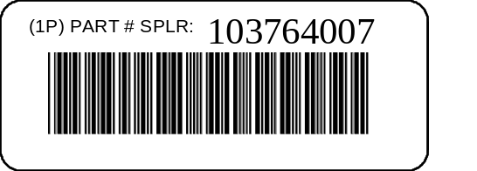
Figure 4-1 Bar Code Symbol Example

When an Application Identifier is used, the human-readable interpretation shall include the data as well as the Application Identifier in parentheses. See Figure 4-2.

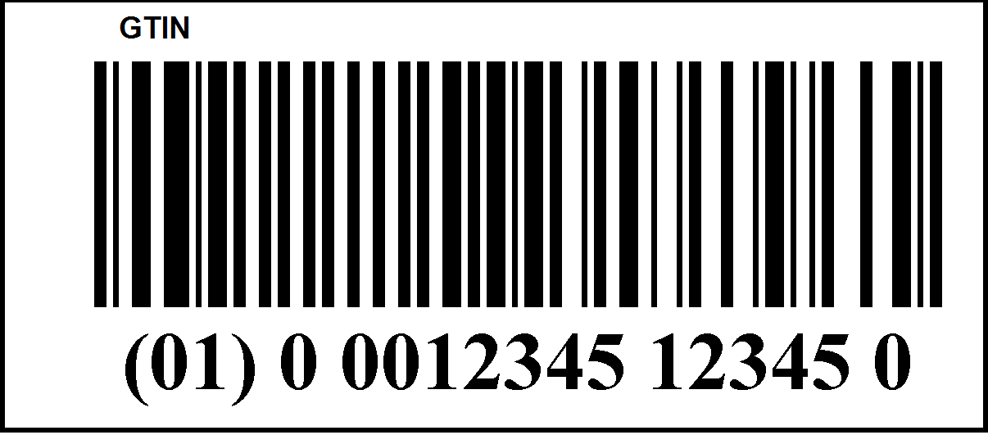
Figure 4-2 Bar Code Example with Application Identifier
For two dimensional symbologies, portions of the data should be shown in the human-readable interpretation when necessary or required by application or industry standards However, human-readable interpretation of two-dimensional symbols is not mandatory.

Symbol Requirements

Symbology Recommendations

Any of the symbologies identified in this document may be used for any altering marking technique. Only matrix symbologies (e.g. Data Matrix) are recommended for altering marking techniques.

Linear Bar Code Symbol Requirements

The linear symbologies referenced in this document are Code 39, EAN/UPC, GS1-128, Code 128, and the GS1 DataBar family. Users contemplating applications of Code 128 with Data Identifiers should become familiar with the issues identified in Annex F. See Figures 4-3 through 4-8.


Figure 4-3 UPC-A Symbol

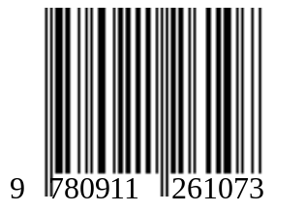
Figure 4-4 EAN-13 Symbol

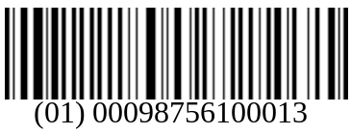

Figure 4-5 GS1-128 Symbol

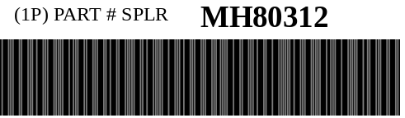
Figure 4-6 Code 39 Symbol

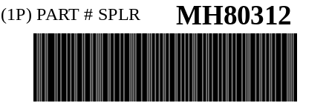
Figure 4-7 Code 128 Symbol


Figure 4-8 GS1 DataBar Symbol

“X” Dimension

The narrow element dimension (X dimension) range should be from 0.19 mm (0.0075 inch) to 0.51 mm (0.020 inch) as determined by the printing capability of the supplier/printer of the label. EAN/UPC symbols are an exception to this; for printing of EAN/UPC symbols the narrow element dimension range should be from 0.25 mm (0.010 inch) to 0.51 mm (0.020 inch). Note that at the smaller X dimensions, care must be given to match the X dimension to an integer multiple of the resolution of the printer. Conformance to bar code print quality requirements shall be determined according to Section 4.4.2.4.

Symbol Height

Bar code symbol height should be no less than 15 percent of the length of the bar code symbol.

EAN/UPC symbols symbol height range should be from 17.05 mm (0.671 inch) to 51.82 mm (2.042 inch).

Quiet Zone

The linear symbol should have minimum quiet zones of 6.4 mm (0.25 inch) adjacent to the start and stop characters. To enable the user to easily scan the bar code symbol, quiet zones shall be a minimum of ten times the narrow element width (X dimension).

UPC-A and EAN-13 symbols shall have quiet zones as follows:
- EAN-13 symbols: left, 11X; right, 7X;
- UPC-A symbols: 9X

Print Quality

Linear bar code print quality shall be measured in accordance with ISO/IEC 15416 in the visible light range (660 nm ± 10 nm) using an aperture size of 0.150 mm (0.006 inches). The minimum overall symbol print quality grade shall be C (1.5), i.e. 1.5/06/660.

When symbols are intended to be read through translucent packaging, the minimum symbol grade shall be met when scanned through the packaging. This requirement is to ensure that the symbol can be read when scanned through protective packaging, such as an ESD container for circuit boards.

Two-Dimensional Symbol Requirements
The two-dimensional symbols referenced in this document are Data Matrix ECC 200, TLC39 TCIF Linked Code 39 and MicroPDF417. The encoding of data in Data Matrix ECC 200 shall be in accordance with ISO/IEC 16022 Symbology Specification- Data Matrix using ECC 200. The encoding of data in MicroPDF417 shall be in accordance with ISO/IEC 24728 Symbology Specification – MicroPDF417.

The encoding of data shall follow the ISO 15434 message format and syntax rules.

Data Matrix Symbol Requirements

The Data Matrix symbols referenced in this document are defined in ISO/IEC 16022.


Figure 4-9 Data Matrix ECC 200 Symbol

4.4.3.1.1 “X” Dimension

The appropriate “X” Dimension for a symbol is determined by many factors including marking area available, surface type, environment and reading device(s) used. The “X” Dimension of a Data Matrix ECC200 symbol is equivalent to the cell size. It is recommended that the user implement their system using the largest “X” Dimension that will enable the symbol to fit in the available area. The minimum open system “X” Dimension shall be 0.13 mm (0.005 inch). “X” Dimension sizes below 0.19 mm (0.0075 inch) or greater than 0.38 mm (0.015 inch) are not recommended because these symbols may be difficult to scan in an open systems environment. Regardless of the element width the symbol shall meet the Symbol Quality requirements of Section 4.4.3.1.6.

4.4.3.1.2 Element Height

The height of any individual cell of the Data Matrix ECC200 symbol should be equal to the “X” Dimension.

4.4.3.1.3 Symbol size

The symbol size should not be greater than 12 mm by 12 mm. The reason for this requirement is to establish a known field of view for reading the label or mark.

The user should implement their system using the largest “X” Dimension that will enable the symbol to fit in the available area, up to the maximum dimensions shown in this table. This will allow for the best possible scanner performance. The particular symbol size that is printed will depend on the amount and type of data encoded. The character count in Table 1.1A includes data overhead characters (specifically, Message Header, Data Identifiers, Data Element Separators, Data and Message Trailer Characters). See Table 4-6.

“X” Dimension
Symbol Size  (with Quiet Zone) | 0.127 mm  (0.005 inch) | 0.150 mm  (0.006 inch) | 0.175 mm  (0.007 inch) | 0.200 mm  (0.008 inch) | 0.250 mm  (0.010 inch)
3 mm x 3 mm | 43 | 25 | 10 | 6 | 3
4 mm x 4 mm | 64 | 52 | 31 | 25 | 10
5 mm x 5 mm | 127 | 64 | 64 | 43 | 25
6 mm x 6 mm | 214 | 127 | 91 | 64 | 43
7 mm x 7 mm | 304 | 214 | 127 | 91 | 64
10 mm x 10 mm | 550 | 418 | 214 | 127 | 91
12 mm x 12 mm | 862 | 550 | 418 | 304 | 214
Table 4-6 Data Matrix ECC200 Alphanumeric Data Capacity

4.4.3.1.4 Quiet Zone

The Data Matrix ECC200 symbol shall have minimum quiet zones of one (1) “X” Dimension width on all four sides of the symbol. It is not the intent of this standard to require additional quiet zone beyond the minimum required by ISO/IEC 16022 Symbology Specification – Data Matrix.

4.4.3.1.5 Error Correction Level

The Data Matrix symbol shall have an error correction level of ECC200 as defined in the ISO/IEC 16022 Symbology Specification - Data Matrix.

4.4.3.1.6 Symbol Quality

The Data Matrix ECC200 symbol shall have a minimum symbol quality of 1.5/08/660/45, where the minimum overall symbol grade is 1.5 (C), measured with an aperture size of 0.20 mm with a lightsource wavelength of 670 nm ± 10 nm, at an angle of incidence of 45 degrees.

Where a special application requires a smaller mark (X dimension smaller than 10 mils or 0.254 mm), it should have a minimum symbol quality of 1.5/05/660/45, where the minimum overall symbol grade is 1.5 (C), measured with an aperture size of 0.125 mm with a lightsource wavelength of 670 nm ± 10 nm, at an angle of incidence of 45 degrees. Applications that incorporate small symbols shall measure all symbols with the 0.125 mm aperture. ISO/IEC 15415 provides additional guidance on selection of grading parameters in application specifications, in paticular the relationship between aperture size and susceptability to gaps and other defects.

The methodology for measuring the symbol quality shall be as specified in ISO/IEC 15415 Bar code print quality specifications - Two dimensional symbols.

The minimally acceptable overall symbol grade of 1.5 applies to the final symbol on the item at the point of receipt. It is recommended that the overall symbol grade, at the point of printing the symbol, be equal to or exceed 2.5 to allow for process variations and possible degradation from packaging, storage, shipping, handling and use.

Guidance for placing direct marks on various substrates can be found in NASA-STD-6002, and NASA-HDBK-6003,, ISO/IEC 24720 and SAE AS9132.

When symbols are intended to be read through translucent packaging, the minimum overall symbol grade shall be met when scanned through the packaging. This requirement is to ensure that the symbol can be read when scanned through protective packaging, such as an ESD container for circuit boards.

4.4.3.1.7 Encryption

Encryption shall not be used for mandatory data fields.

4.4.3.1.8 Character Set

The character set shall be upper case alphabetic characters, numeric digits, and the eight characters (dash, period,space, $, /, +, *, and %), as well as the recommended field separators, record separators, segment terminators and compliance indicator. A table of these characters and their hexadecimal and decimal equivalent is included as Annex C. It is recommended that the resultant data stream from scanning a Data Matrix symbol follow the syntax described in ISO/IEC 15434.

MicroPDF417 Symbol Requirements

The MicroPDF417 symbols referenced in this document are defined in the ISO/IEC 24728, Bar code symbology specification – MicroPDF417. See Figure 4-10 MicroPDF 417 Symbol.

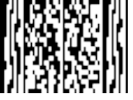
Figure 4-10 MicroPDF 417 Symbol
4.4.3.2.1 “X” Dimension

The appropriate “X” Dimension for a symbol is determined by many factors including marking area available, surface type, environment and reading device(s) used. It is recommended that the user implement their system using the largest “X” Dimension that will enable the symbol to fit in the available area. The minimum open system “X” Dimension shall be 0.127 mm (0.005 inch). “X” Dimension sizes below 0.25 mm (0.010 inch) are not recommended because symbols with these small “X” Dimensions cause a reduced depth of field and may be difficult to scan in an open systems environment. Regardless of the element width the symbol shall meet the Print Quality requirements of Section .

4.4.3.2.2 Element Height

The MicroPDF417 symbol should have a bar height (height of the symbol element) two times the width of the narrow element (“X” dimension).

4.4.3.2.3 Quiet Zone

MicroPDF417 symbols should have minimum quiet zones of one (1) “X” Dimension on all four sides of the symbol. It is not the intent of this standard to require an additional quiet zone beyond the minimum required by the ISO/IEC 24728, Bar code symbology specification – MicroPDF417.

4.4.3.2.4 Error Correction Level

For MicroPDF417 symbols error correction levels are automatically selected in accordance with the ISO/IEC 24728, Bar code symbology specification – MicroPDF417.

4.4.3.2.5 Print Quality

Two-dimensional symbols compliant with this section shall have a minimum Print Quality of 1.5/05/660, where the minimum overall symbol grade is 1.5 (C), measured with an aperture size of 0.127 mm (0.005 inch), with a lightsource wavelength of 670 nm ±10 nm. The methodology for measuring the print quality shall be as specified in ISO/IEC 15415 and the ISO/IEC 24728, Bar code symbology specification – MicroPDF417.

The minimally acceptable overall symbol grade of 1.5 applies to the final symbol on the item at the point of receipt. It is recommended that the overall symbol grade, at the point of printing the symbol, be equal to or exceed 2.5 to allow for process variations and possible degradation from packaging, storage, shipping, and handling.

When symbols are intended to be read through translucent packaging, the minimum overall symbol grade shall be met when scanned through the packaging. This requirement is to ensure that the symbol can be read when scanned through protective packaging, such as an ESD container for circuit boards.

4.4.3.2.6 Encryption

Encryption shall not be used for mandatory data fields.

4.4.3.2.7 Character Set

The character set shall be upper case alphabetic characters, numeric digits, and the eight characters (dash, period, space, $, /, +, *, and %), as well as the recommended field separators, record separators, segment terminators and compliance indicator. A table of these characters and their hexadecimal and decimal equivalent is included as Annex C.

Composite Symbol Requirements

The Composite symbols referenced in this document are the GS1 Composite Symbols, as defined in ISO/IEC 24723, consisting of either a UPC-A, UPC-E, EAN-13, EAN-8, GS1-128, GS1-DataBar symbols as the Composite Linear Component and a variant of MicroPDF417 (CC-A and CC-B) or PDF417 (CC-C) as the 2D Composite Component. The 2D Composite Component cannot be used by itself.

Composite Symbols Dimensions

The dimensions of composite symbols will be determined by a number of factors. The width of the symbol will be determined by the choice of linear symbology. The height of the symbol will be determined by the width of the chosen linear symbol and the amount and mix of the alpha and numeric data to be encoded. A wider linear symbol allows more data to be encoded in each row of the 2D Composite Component. For example, an GS1 DataBar Limited symbol is wider than an GS1 DataBar Stacked Omnidirectional symbol. Numeric data can be encoded more efficiently than alphanumeric data and will result in a smaller symbol.

Cell Size and “X” Dimension

The minimum open system “X” Dimension shall be 0.127 mm (0.005 inch). “X” Dimension sizes of 0.168 mm (0.0066 inch) or greater are recommended because symbols with smaller “X” dimensions cause a reduced depth of field and may be difficult to scan in an open systems environment. Regardless of the “X” Dimension chosen, the symbol shall meet the Print Quality requirements of Section 4.4.4.5.

Symbol Height

The linear components of Composite symbols have a minimum symbol height defined in their respective symbology specifications (see Clause 4 References). These minimum heights support all scanning technologies, including wand scanning and omni-directional Point of Sale scanning. For the applications supported by this guideline, a height to width aspect ratio of 15% will provide optimum performance and is recommended when space constraints permit.

The MicroPDF417 based Composite Components (e.g., CC-A and CC-B) shall have a minimum row height (height of the symbol element) of two times the width of the narrow element (“X” dimension). PDF417 based Composite Components shall have a minimum row height (height of the symbol element) of three times the width of the narrow element (“X” dimension).

Quiet Zone

The linear components have a minimum quiet zone requirement defined in their respective symbology specifications.

CC-A and CC-B Composite Components have a minimum width requirement of one “X” Dimension for the left and right quiet zone. CC-C Composite Components have a minimum width requirement of two times the “X” Dimension for the left and right quiet zone. No quiet zone is required above or below a GS1 Composite Symbol.

Print Quality

GS1 Composite Symbols shall have a minimum Print Quality of 1.5/06/660, where the minimum overall symbol grade is 1.5 (C), measured with an aperture size of 0.150 mm, , with a lightsource wavelength of 670 nm ± 10 nm. The methodology for measuring the print quality shall be as specified in the ISO/IEC 15416, and the applicable symbology specification.

The minimally acceptable overall symbol grade of 1.5 applies to the final symbol on the item at the point of receipt. It is recommended that the overall symbol grade, at the point of printing the symbol, be equal to or exceed 2.5 to allow for process variations and possible degradation from packaging, storage, shipping, and handling.

When symbols are intended to be read through translucent packaging, the minimum overall symbol grade shall be met when scanned through the packaging. This requirement is to ensure that the symbol can be read when scanned through protective packaging, such as an ESD container for circuit boards.

Error Correction Level

CC-A and CC--B Composite Components shall incorporate the number of error correction codewords defined International Symbology Specification - GS1 Composite Symbols. CC-C Composite Components shall meet or exceed the minimum error correction level recommended in the ISO/IEC 15438, Automatic Identification and Data Capture Techniques -International Symbology Specifications PDF 417.

Encryption

Encryption shall not be used for mandatory data fields.

Character Set

The character set shall be upper case alphabetic characters, numeric digits, and the six characters (dash, period, /, Comma, Space and *), as well as the recommended field separators, record separators, segment terminators and compliance indicator. A table of these characters and their hexadecimal and decimal equivalent is included as Annex C. It is recommended that the resultant data stream from scanning a GS1 Composite Symbol follow the syntax described in ISO/IEC 15434 and not that of GS1-128 emulation.

Bibliography (Informative)

ANSI/CEA-706-A Component Marking Standard,

CEA-802 Product Marking Standard

GR-383-CORE COMMON LANGUAGE® Equipment Codes (CLEI™ Codes)— Generic Requirements for Bar Code Labels,

GR-485-CORE COMMON LANGUAGE® Equipment Codes (CLEI™ Codes)— Generic Requirements for Processes and Guidelines,

MIL-STD-130 Department of Defense Standard Practice Identification Markings of U.S. Military Property

TCIF-00-003 Product Marking Implementation Guideline

(Normative)

Label Adhesive Characteristics, Mark Durability and Recyclability

The following requirements and tests are intended to ensure that labels and marks can withstand extended long term exposure to a variety of indoor environments, which could include an assembly process, remain affixed to products and are scannable for the intended life of the product.

NOTE--Additional tests may be required for specific exports to specific countries.

General

This standard covers the manufacturing and printing requirements for pressure sensitive adhesive backed bar code labels intended primarily to automate product tracking, inventory control and serialized warranty systems. Labels being tested for conformance to Sections A.3.4 and A.3.5 are intended to withstand harsh environment exposures.

It is the responsibility of the trading partners to agree upon specifications of labels covered by this standard and to test the label in their operating environment prior to acceptance.

All labels shall be easily separable from the release liner without damage, be smudge-resistant and be reasonably flat. Label stock should be examined visually for evidence of particles of paper, dust, or other foreign material that would adversely affect print quality.

Observed or calculated values obtained from analysis, measurement, or test shall be rounded off in accordance with the Rounding-Off Method per ASTM E 29 to the nearest unit in the last right-hand place of figures used in expressing the specified limit.

Where reference is made to an ASTM designation in this standard, the issue listed in the latest published ASTM index to standards shall apply unless otherwise specified.

Generation of voltage levels significant enough to cause ESD and damage to sensitive components can occur when using pressure sensitive labels. If meeting the requirements for ESD protected areas outlined in EIA-625 Requirements For Handling Electrostatic-Discharge-Sensitive [ESDS] Devices is required, using static control measures such as static dissipative labels or air ionization may be necessary.

Requirements

The labels shall be capable of meeting the requirements of Clauses 4.4, Symbol Requirements and A.2, Requirements when tested in accordance with Clause A.3, Methods of Test.

Labels shall not show delamination within the label, blistered areas, or chipped edges. The bar code symbol and all alphanumeric characters printed on each label should be black on white substrate. Bar code labels shall be scannable and reasonably free from scratches, marks,voids, dots or misplaced color. All labels should have minimum outside corner radii of 0.03 inch (0.76 mm) unless otherwise specified.

Label Thickness

The maximum overall thickness of the label (not including the release liner) shall be 0.22 mm (0.0085 inch).

Nature of Adhesive

The adhesive shall be pressure sensitive and permanent. It shall be applied in a uniform layer and be free from bubbles and foreign matter.

Adhesion Strength

The minimum initial adhesion strength two hours ±10 minutes after application at ambient room temperature and humidity shall be 0.23 Newton/mm. (25.0 oz/inch).

The minimum adhesion strength after stainless-steel test panel (ASTM D1000, Section 40.2) application and conditioning, per Section A.3.3, shall be 0.44 Newton/mm (40.0 oz/inch).

The labels shall show no evidence of delamination, bubbles, adhesive migration or degraded image quality for either the text or the bar code symbol.

Although the test requirements specify stainless steel test panels, these adhesion tests should also be conducted using the target substrate to assure appropriate performance. Rough or textured surface may require increases in adhesive thickness, for example.

Label Requirements after Conditioning and Printed Circuit Board Processing

The labels shall meet the minimum print quality requirements of Section 4.4.2.4 after conditioning and passing through the printed circuit board processing cycles.

The minimum adhesion strength after test panel application and conditioning shall be 0.44 Newton/mm (40.0 oz/inch).

The labels shall show no evidence of delamination, bubbles, adhesive migration or degraded image quality for either the text or the bar code symbol.

Abrasion

Labels or marks shall be capable of meeting the requirements of the appropriate clauses in 4.4, Symbol Requirements after being subjected to the abrasion test in clause A.3.5.

Method of Test

Label Thickness

Conformance to the overall label thickness requirements shall use the ASTM D 374, Method C as referenced and modified in ASTM D 1000. Measure the thickness of the label plus the release liner, the release liner alone, and obtain the label thickness by subtraction.

Nature of Adhesive

The general nature of the adhesive shall be permanent, pressure sensitive and free from bubbles, voids, and foreign matter.

Adhesive Strength

The determination of the adhesive strength of test labels consist of the proper test label size, panel preparation and panel conditioning for the appropriate application.

Test Label Size

A minimum label size of 10 mm (0.25 inch) by 25.4 mm (1.0 inch) should be used for adhesion measurements. When possible, it is recommended to use the actual label size intended for the application. Obtain a rubber-covered steel roller (per ASTM D-100 Section 40.3) and prepare at least 2 stainless steel panels (per ASTM D 1000, Method A).

Label Test Panel Preparation

Remove labels from the release liner and apply at least four labels to an ASTM stainless steel test panel, and roll per ASTM D 1000 Section 42 taking care to leave approximately 3 mm (0.125 inch) of release liner on each label for clamping purposes.

Initial Adhesion Strength

Remove at least three labels from the release liner, apply them to 1 or more stainless steel panels, and roll per ASTM D 1000 Section 42 taking care to leave approximately 3 mm (0.125 inch) of release liner on each label for clamping purposes. In 2 hours (±10 minutes), measure the adhesion strength to conform to the requirements of A.2.3 using a crosshead tensile tester making a 90-degree peel (Figure A-1 90 Degree Peel Test Apparatus at a rate of 50 mm (2 inch) per minute using a wire length of approximately 762 mm (30 inch). Calculate the average value of adhesion.

Short Term 100 Degrees Celsius - Medium Temp

Place the panel in an oven maintained at 100 degrees Celsius (212 degrees Fahrenheit). At the end of 168 hours, remove the panel and allow it to cool to room temperature. Within 1 to 3 hours of removing the panel from the conditioning chamber, measure the bar code print quality of the labels on one panel in accordance with Section 4.4.2.4 or as appropriate and the adhesion strength of the labels on the other panel in accordance with Section A.3.3 to determine conformance with the requirements of Section A.2.3. Determine the adhesion strength by measuring the adhesive strength of at least 3 test labels and averaging the results for the overall value. The labels shall show no evidence of self-lifting, delaminating, smudging, or discoloring after conditioning.

Short Term 49 Degrees Celsius 95% RH - Temp/Humidity

Place the panel in an oven maintained at 49 degrees Celsius (120 degrees Fahrenheit) and a controlled relative humidity of 95% non-condensing. At the end of 96 hours remove the panel and allow it to cool to room temperature. Within 1 to 3 hours of removing the panel from the conditioning chamber, measure the bar code print quality of the labels on one panel in accordance with Section 4.4.2.4 or as appropriate and the adhesion strength of the labels on the other panel in accordance with Section A.3.3 to determine conformance with the requirements of Section A.2.3. Determine the adhesion strength by measuring the adhesive strength of at least 3 test labels and averaging the results for the overall value. The labels shall show no evidence of self-lifting, delaminating, smudging, or discoloring after conditioning.

Long Term 82 Degrees Celsius - Medium Temp

Place the panels in a circulating air oven at 82 degrees Celsius ± 3 degrees Celsius (180 degrees Fahrenheit ± 5 degrees Fahrenheit. At the conclusion of 30 days, measure the bar code print quality of the labels on one panel in accordance with Section 4.4.2.4 or as appropriate and the adhesion strength of the labels on the other panel in accordance with Section A.3.3 to determine conformance with the requirements of Section A.2.3. Determine the adhesion strength by measuring the adhesive strength of at least 3 test labels and averaging the results for the overall value. The labels shall show no evidence of self-lifting, delaminating, smudging, or discoloring after conditioning.

Long Term 32 Degrees Celsius 95% RH - Temp/Humidity

Place two panels of labels in a circulating air oven at 32 degrees Celsius ± 3 degrees Celsius (90 degrees Fahrenheit ± 5 degrees Fahrenheit and 95 ± 2 percent relative humidity non-condensing. At the conclusion of 30 days, measure the bar code print quality of the labels on one panel in accordance with Section 4.4.2.4 or as appropriate and the adhesion strength of the labels on the other panel in accordance with Section A.3.3 to determine conformance with the requirements of Section A.2.3. Determine the adhesion strength by measuring the adhesive strength of at least 3 test labels and averaging the results for the overall value. The labels shall show no evidence of self-lifting, delaminating, smudging, or discoloring after conditioning.

Additional Label Conditioning Tests for Labels or Marks Required to Withstand Printed Circuit Board Processes

The tests described in the subsections of Section A.3.4 represent a baseline to approximate the performance of pressure-sensitive labels in a variety of application processes. These tests are not intended to precisely duplicate the processes encountered in a manufacturing environment. To precisely predict the performance of the label it is recommended to test the process used in the intended manufacturing application.

Short Term 260 Degrees Celsius - High Temp - for Bottom Side Labels for Printed Circuit Boards

This test applies only to labels applied to the bottom side of printed circuit boards that are intended to withstand wavesolder processes. Place six labeled, printed ASTM D1000 test panels in an oven maintained at 260 degrees Celsius (500 degrees Fahrenheit). After seven minutes, remove the printed test panels and allow them to cool to room temperature. Within one to three hours, measure the bar code print quality of the labels in accordance with Section 4.4.2.4 or as appropriate. Determine the adhesion strength by measuring the adhesive strength of at least 3 test labels using a crosshead tensile tester making a 90-degree peel (see Figure A-1) at a rate of 50 mm (2 inch) per minute using a wire length of approximately 762 mm (30 inch). Calculate the average value of adhesion to determine conformance to the requirements specified in Section A.2.4. The labels shall show no evidence of self-lifting, delaminating, smudging, or discoloring after conditioning.

If the requirements of Section 4.4 are met, then subject one of the labeled test panels to the short term 100 degree Celsius test described in Section A.3.3.4 and the remaining labeled test panels to the short term 49 degree Celsius 95% RH test described in Section A.3.3.5. Determine conformance to the bar code print quality requirements of Section 4.4.2.4 or as appropriate and the adhesion requirements of Section A.2.4.

If the labels pass both short term tests then simultaneously subject a set of labeled test panels that has successfully gone through the short term 260 degree Celsius - High Temp test to each of the Long Term tests described in Section A.3.3.6 and A.3.3.7. Determine conformance to the bar code print quality requirements of clause 4.4.2.4 or as appropriate and the adhesion requirements of Section A.2.4.

Initial Cleaning

Apply at least four labels to sample printed circuited boards. Subject the circuit board to an aqueous water cleaning process and then proceed to submit the labels to the IR Reflow test described in Section A.3.4.3. The substitution of other cleaners for the aqueous water cleaner may adversely affect the adhesive and/or bar code print quality of the labels. When such a substitution is necessary, the labels shall be inspected to meet the requirements of Section A.2.4 after the initial cleaning cycle.

IR Reflow

Subject the labels to an IR reflow process test that meets the conditions in Table A-1. The temperatures in Table A-1 are the actual board temperatures.

Conditions | Temperature
Conditions | Degrees Celsius | Equivalent Degrees Fahrenheit
Preheat Temperature | 150 +/- 5 | 302 +/- 8
Peak Temperature | 232 +/- 2.5 | 450 +/- 4.5
Maximum  Temperature Rise | 2 degrees per second | 4 degrees per second
Time Above  180 degrees Celsius | 120 seconds +/- 5 seconds
Table A-1 IR Reflow Conditions & Temperatures

Post IR Reflow Cleaning

Within one hour of completing the IR Reflow test, subject the labels to an aqueous water cleaning process and proceed to subject the labels to the Wavesolder test described in Section A.3.4.5. The substitution of other cleaners for the aqueous water cleaner may adversely affect the adhesive and/or bar code print quality of the labels. When such a substitution is necessary, the labels shall be inspected to meet the requirements of Section A.2.4 after the Post IR Reflow cleaning cycle.

Wavesolder

Subject the labels to a wavesolder process at the conditions indicated in Table A-2. Within one hour of the completion of the Wavesolder test, subject the labels to Post Wavesolder Cleaning as described in Section A.3.4.6.

Conditions | Temperature
Conditions | Degrees Celsius | Equivalent Degrees Fahrenheit
Preheat Temperature | 90 | 194
Maximum Preheat Temperature Rise | 2 degrees per second | 4 degrees per second
Solder Temperature | 260 | 500
Conveyor Angle | 7 degree angle from the horizontal plane
Process Time | 4 to 9 minutes
Table A-2 Wavesolder Conditions

Post Wavesolder Cleaning

Subject the labels to an aqueous water cleaning process. The substitution of other cleaners for the aqueous water cleaner may adversely affect the adhesive and/or bar code print quality of the labels. When such a substitution is necessary, the labels shall be inspected to meet all the requirements of Section A.2.4, after the Post Wavesolder cleaning cycle.

Abrasion test

The Teledyne Taber Abraser Model 5130 has been found to be a suitable apparatus for abrasion testing. The components needed for this abrasion procedure are:

- Specimen Holder E100-125.
- Specimen Plate S-16.
- Abrading Wheel CS-10.

- The specimen plate shall be clean and dry. Two labels shall be attached to the specimen plate in such a position that the path of abrasion covers a maximum area of the bar code symbol. The labels shall not be trimmed, rather they are allowed to extend beyond the path of the abrasive wheel. The test labels shall be attached to the specimen plate in accordance with ASTM D-1000, where applicable.
- When possible the test will be conducted in atmosphere controlled to 50 percent humidity and 21-23 degrees Celsius (70-74 degrees Fahrenheit). The test samples should be conditioned in the test atmosphere for at least 24 hours before testing.
- Select one character from the middle of the bar code symbol on each label and measure all the bars and spaces.
- The specimen plate shall be rotated beneath the abrasion wheels for a period of 100 cycles ± 1 cycle with 250 grams of weight. After the required number of cycles, remove the specimen plate and examine the test character on each label.
- Following the abrasion test, linear symbols must meet the print quality requirements of the applicable Section 4.4.2.4. Following the abrasion test two-dimensional symbols must meet the print quality requirements of the applicable Section.

Label Recyclability

When possible, the label material, printing ink and adhesive should be specified to be recyclable materials. In particular, care should be taken that all label materials be compatible with the substrate packaging material for purposes of recyclability.

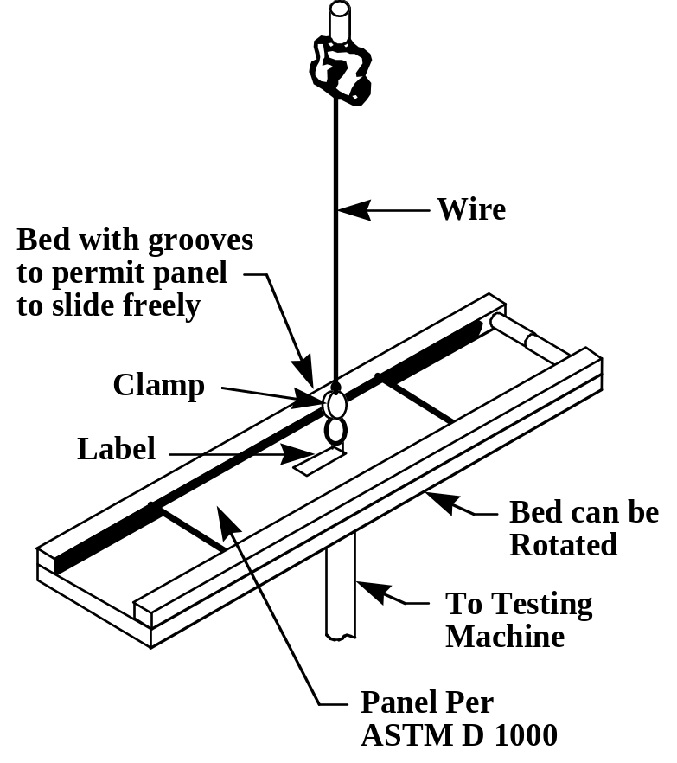

Figure A-1 90 Degree Peel Test Apparatus

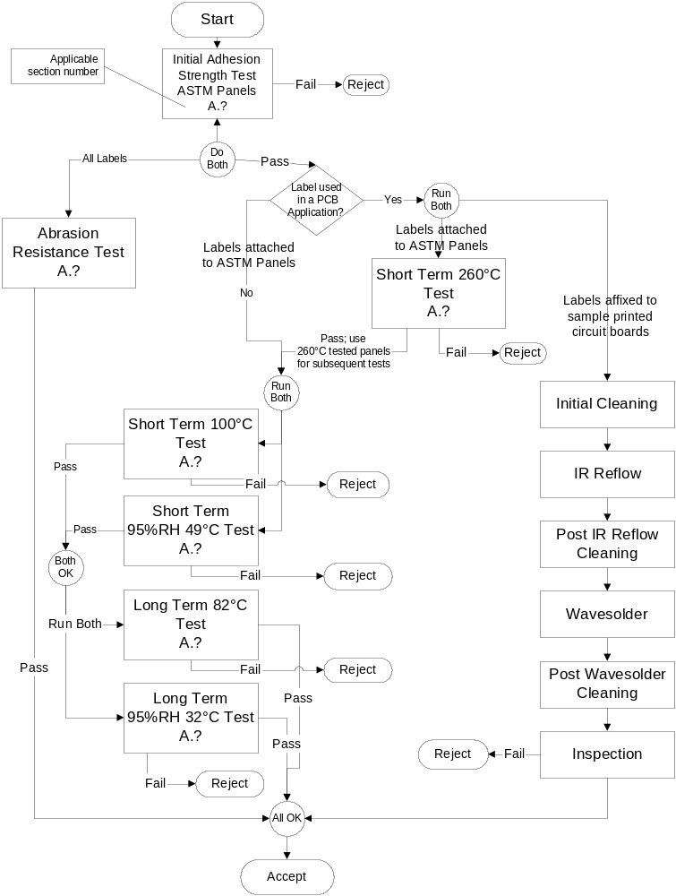
Figure A-2 Flow Chart

(Normative)

Commonly Used Identifiers (Informative, not part of standard)

Note: This is a partial listing. The complete listing is included in ANS MH10.8.2.

Data Identifier | Identifier Description | Application Identifier
5D | ISO format YYMMDD immediately followed by an ANSI X12.3 Data Element Number 374 Qualifier providing a code specifying type of date (e.g., manufacture date “094”) | 11  (Production Date)
6D | ISO format YYYYMMDD immediately followed by an ANSI X12.3 Data Element Number 374 Qualifier providing a code specifying date type (e.g., manufacture date “094”) | 906D
4L | Country of Origin, two-character ISO 3166 country code | 422 (3-digit ISO 3166 Code)
N | National/NATO Stock Number (NSN) | 7001
P | Item Identification Code assigned by Customer | 241
1P | Item Identification Code assigned by Supplier | 01  (GTIN-14)
2P | Code assigned to specify the revision level for an Item (e.g., engineering change level, edition, or revision) | 240
3P | Combined manufacturer identification code/item code (12 digit U.P.C. data preceded by the digit zero [0]) | 01  (GTIN-14)
8P | 14-digit UCC/EAN format for Product Shipping Container Symbol code structure | 01  (GTIN-14)
9P | Combined DUNS-9 supplier identification and item code assigned by the supplier | 909P
11P | 10-character (alphanumeric) CLEI Code for Telecommunications Equipment | 9011P
Q | Quantity, Number of Pieces, or Amount (numeric only) (unit of measure and significance mutually defined) | 30
7Q | Quantity, Amount, or Number of Pieces in the format: Quantity followed by the two character ANSI X12.3 Data Element Number 355 Unit of Measurement Code
S | Serial number or code assigned by the Supplier to an entity for its lifetime, (e.g., computer serial number, traceability number, contract tool identification) | 21
1S | Additional code assigned by the Supplier to an entity for its lifetime (e.g., traceability number, computer serial number) | 250
1T | Traceability Number assigned by the Supplier to identify/trace a unique group of entities, (e.g., lot, batch, heat) | 10
V | Supplier Code assigned by Customer | 90V
1V | Supplier Code assigned by Supplier | 01  (GTIN-14)
3V | Company Code as assigned by the Uniform Code Council (UCC) or EAN international | 95
12V | 9-digit DUNS number as assigned by Dun & Bradstreet to identify a manufacturer | 9012V
13V | 9-digit DUNS number as assigned by Dun & Bradstreet to identify a supplier | 9013V
17V | U.S. DoD CAGE Number | 9017V
18V | Identification of a party to a transaction in which the data format consists of two concatenated segments. The first segment is the unique code assigned to an issuing agency by NEN in accordance with ISO/IEC 15459, the second segment is a unique entity identification assigned in accordance with rules established by the issuing agency (see http://www.nen.nl/nl/pro/line/ISOIEC15459_and_EN1572_guide.html) | 9018V
20V | Identification of a party to a transaction as identified in 18V, followed by a plus (+) character followed by one or more code values from EDIFACT Code List 3035 “Party Qualifier”, separated by plus (+) characters (Never to be concatenated with other DIs in a linear symbol or other media where the concatenation character is a plus (+) character) | 9020V

(Informative, Not Part of Standard)

Subset of ASCII/ISO 646 (Table of Hexadecimal and Decimal Values)

HEX | DEC | ASCII / ISO 646 | HEX | DEC | ASCII / ISO 646 | HEX | DEC | ASCII / ISO 646
00 | 00 | NUL | 30 | 48 | 0 | 60 | 96 | '
01 | 01 | SOH | 31 | 49 | 1 | 61 | 97 | a
02 | 02 | STX | 32 | 50 | 2 | 62 | 98 | b
03 | 03 | ETX | 33 | 51 | 3 | 63 | 99 | c
04 | 04 | EOT | 34 | 52 | 4 | 64 | 100 | d
05 | 05 | ENQ | 35 | 53 | 5 | 65 | 101 | e
06 | 06 | ACK | 36 | 54 | 6 | 66 | 102 | f
07 | 07 | BEL | 37 | 55 | 7 | 67 | 103 | g
08 | 08 | BS | 38 | 56 | 8 | 68 | 104 | h
09 | 09 | HT | 39 | 57 | 9 | 69 | 105 | i
0A | 10 | LF | 3A | 58 | : | 6A | 106 | j
0B | 11 | VT | 3B | 59 | ; | 6B | 107 | k
0C | 12 | FF | 3C | 60 | < | 6C | 108 | l
0D | 13 | CR | 3D | 61 | = | 6D | 109 | m
0E | 14 | SO | 3E | 62 | > | 6E | 110 | n
0F | 15 | SI | 3F | 63 | ? | 6F | 111 | o
10 | 16 | DLE | 40 | 64 | @ | 70 | 112 | p
11 | 17 | DC1 | 41 | 65 | A | 71 | 113 | q
12 | 18 | DC2 | 42 | 66 | B | 72 | 114 | r
13 | 19 | DC3 | 43 | 67 | C | 73 | 115 | s
14 | 20 | DC4 | 44 | 68 | D | 74 | 116 | t
15 | 21 | NAK | 45 | 69 | E | 75 | 117 | u
16 | 22 | SYN | 46 | 70 | F | 76 | 118 | v
17 | 23 | ETB | 47 | 71 | G | 77 | 119 | w
18 | 24 | CAN | 48 | 72 | H | 78 | 120 | x
19 | 25 | EM | 49 | 73 | I | 79 | 121 | y
1A | 26 | SUB | 4A | 74 | J | 7A | 122 | z
1B | 27 | ESC | 4B | 75 | K | 7B | 123 | {
1C | 28 | FS | 4C | 76 | L | 7C | 124 | |
1D | 29 | GS | 4D | 77 | M | 7D | 125 | }
1E | 30 | RS | 4E | 78 | N | 7E | 126 | ~
1F | 31 | US | 4F | 79 | O | 7F | 127 | DEL
20 | 32 | SP | 50 | 80 | P
21 | 33 | ! | 51 | 81 | Q
22 | 34 | " | 52 | 82 | R
23 | 35 | # | 53 | 83 | S
24 | 36 | $ | 54 | 84 | T
25 | 37 | % | 55 | 85 | U
26 | 38 | & | 56 | 86 | V
27 | 39 | ' | 57 | 87 | W
28 | 40 | ( | 58 | 88 | X
29 | 41 | ) | 59 | 89 | Y
2A | 42 | * | 5A | 90 | Z
2B | 43 | + | 5B | 91 | [
2C | 44 | , | 5C | 92 | \
2D | 45 | - | 5D | 93 | ]
2E | 46 | . | 5E | 94 | ^
2F | 47 | / | 5F | 95 | _
Values shown in BOLD are specifically supported by this standard.

(Informative, Not Part of the Standard)

User Guidance for Implementation of the ISO 15434 Data Syntax

ISO 15434 employs as a header, the three character sequence [)>. ISO 15434 further employs the following special characters as separators and terminators: <GS>, <FS>, <RS>, <US>, and <EOT>. These characters may be difficult to implement without specific knowledge of the programming language and character sets employed

Information and guidance on the use of ISO 15434 special characters can be found by contacting specific printer or software manufacturers or by referring to the Internet Web site http://www.autoid.org/ansi_mh10sc8_special_characters.htm.

(Informative, Not Part of Standard)

Data Format for GTIN 12, GTIN 13) and GTIN 14

One set of formats recommended within this standard is that of GS1 Global Trade Item Number (GTIN). UPC-A and UPC-E is a 12-digit code. EAN-13 is a 13-digit code. Coding for levels of packaging above an individual item is referred to as GTIN 14. This coding structure provides for international article uniqueness at all packaging levels. An example of this uniqueness is shown in Table E-1. In both examples, all three codes are logically equivalent. If read into a database as a numeric 14-digit field, the data would be right-hand justified, zero-filled to the left. Read into such a numeric field each structure is now identical. Note: Begining on 1 January 2005, users will be required to process the EAN-13 and EAN-8 symbols in addition to the UPC-A and UPC-E symbols at the point of sale. At the same time, it is recommended that data bases be updated to allow for the full 14 digit representation of the GTIN. Please refer to the latest GS1 General Specifications for additional information.

Data Structures | GTIN Format*
 | T₁ | T₂ | T₃ | T₄ | T₅ | T₆ | T₇ | T₈ | T₉ | T₁₀ | T₁₁ | T₁₂ | T₁₃ | T₁₄
GTIN-14 | N₁ | N₂ | N₃ | N₄ | N₅ | N₆ | N₇ | N₈ | N₉ | N₁₀ | N₁₁ | N₁₂ | N₁₃ | N₁₄
GTIN-13 | 0 | N₁ | N₂ | N₃ | N₄ | N₅ | N₆ | N₇ | N₈ | N₉ | N₁₀ | N₁₁ | N₁₂ | N₁₃
GTIN-12 | 0 | 0 | N₁ | N₂ | N₃ | N₄ | N₅ | N₆ | N₇ | N₈ | N₉ | N₁₀ | N₁₁ | N₁₂
GTIN-8 | 0 | 0 | 0 | 0 | 0 | 0 | N₁ | N₂ | N₃ | N₄ | N₅ | N₆ | N₇ | N₈

*T represents the position of each individual digit in a computer file format, N represents the position of each individual digit in a given data structure, and 0 represents a filler digit.
Table E-1 GS1 Coding Conventions
As shown in Table E-1, GS1 coding structures are able to provide for article uniqueness across the supply chain. The United States initially developed UPC-A as a 12-digit code. The symbol is constructed from 30 bars and 29 intervening spaces (Figure E-1) where each character is comprised of 2 bars and 2 spaces over seven modules (Figure E-2). The symbol uses odd-parity (Table E-2- Number Set A) for the left side of the symbol and even parity (Table E-2 Number Set C) for the right side of the symbol. One of the original purposes for different parity patterns on left and right sides of the symbol was to enable scanners to be able to read the left side with one scanning path, the right side with another scanning path, and to enable the decoding software to reassemble the entire coded message.

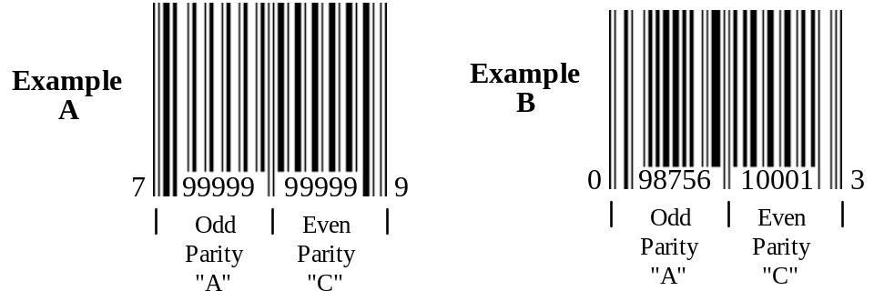
Figure E-1 UPC-A Parity

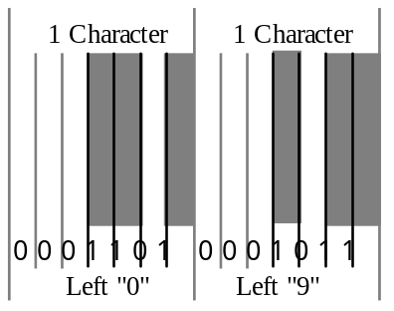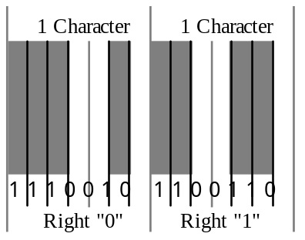
Figure E-2 EAN/UPC Character Structure (7 modules – 2 bars & 2 spaces)

Character Value  Value | Number  Set A | Number  Set B | Number  Set C
0 | 0001101 | 0100111 | 1110010
1 | 0011001 | 0110011 | 1100110
2 | 0010011 | 0011011 | 1101100
3 | 0111101 | 0100001 | 1000010
4 | 0100011 | 0011101 | 1011100
5 | 0110001 | 0111001 | 1001110
6 | 0101111 | 0000101 | 1010000
7 | 0111011 | 0010001 | 1000100
8 | 0110111 | 0001001 | 1001000
9 | 0001011 | 0010111 | 1110100
Table E-2 EAN/UPC Character Parity Assignments

The GS1 assigns member companies a “Company Prefix” which is constructed by concatinating the GS1 Prefix (Table E-3) with the assigned Company Number. The resulting GS1 Company Prefix is globally unique within the GS1 System. Since 2002, the Company Number, assigned by the UCC, is no longer fixed at 5 digits in length, it varies in length.

Synopsis of GS1 Prefixes
GS1 Prefixes |  | Significance
000 - 019 |  | GS1 Prefix* (used to create U.P.C. Company Prefixes)
02 |  | GS1 Variable Measure Trade Item identification for restricted distribution
030 - 039 |  | GS1 Prefix
04 |  | GS1 restricted circulation number within a company
05 |  | GS1 US coupon identification
060 - 099 |  | GS1 Prefix (used to create U.P.C. Company Prefixes)
100 - 139 |  | GS1 Prefix
140 - 199 |  | Reserve
20 - 29 |  | GS1 restricted circulation number within a geographic region
300 - 969 |  | GS1 Prefix
970 - 976 |  | Reserve
977 |  | ISSN standard numbering (serial publications)
978 - 979 |  | ISBN standard numbering (books)
980 |  | GS1 identification of Refund Receipts
981-984 |  | GS1 coupon identification for common currency areas
985 - 989 |  | Reserved for further GS1 coupon identification
99 |  | GS1 coupon identification

* Starting from GS1 Company Prefix 00 00100 to avoid collision with GTIN-8 Identification Numbers.
Note: GS1 Company Prefixes 00 00000 and 00 01000 to 00 07999 have specific application for Locally Assigned Codes (LACs) or Retailer Zero-Suppressed Codes (RZSCs).

The design of UPC-A in the U.S. led to the desire to have a single system world-wide, though a concern developed that there was insufficient capacity in this 12-digit number to support world-wide numbering. A method was developed to expand the 12-digit code to a 13-digit code through the creation of another number set (Table E-2, Number Set B) and deriving the 13th digit through individual character parity of the left side of the symbol. The left-hand side of an EAN-13 symbol encodes six 2 bar / 2 space / over seven modules characters. Both UPC-A and EAN-13 have 30 bars and 29 intervening spaces. Table E-4 shows the technique employed by GS1 to derive the 13th digit in EAN-13.

Value of 13th Digit | Parity Number Sets of Digits 7 through 12
Value of 13th Digit | 12 | 11 | 10 | 9 | 8 | 7
1 | A | A | B | A | B | B
2 | A | A | B | B | A | B
3 | A | A | B | B | B | A
4 | A | B | A | A | B | B
5 | A | B | B | A | A | B
6 | A | B | B | B | A | A
7 | A | B | A | B | A | B
8 | A | B | A | B | B | A
9 | A | B | B | A | B | A
Table E-4 EAN-13, Character 13, Value Assignments

Table E-6 and Table E-7 are examples that show how this 13th digit might be developed for both a U.S. and a French company.

Character Position 13 12 11 10 9 8 7 6 5 4 3 2 1
Parity Number Set A A A A A A C C C C C C
Character (Example #A) 0 7 9 9 9 9 9 9 9 9 9 9 9
Character (Example #B) 0 0 9 8 7 5 6 1 0 0 0 1 3

Character position 1 is the Modulus 10 check digit.
Character positions 2 though 6 are the manufacturer assigned item code
Character positions 7 through 11 are the UPC Manufacturer ID Number
Character position 12 is the UPC Number System Character
Character position 13 is the filled "0" value of a 12-digit code in a 13-digit field
Note: The leading digit value “0” is reserved for symbols encoding GTIN-12 Element Strings.

Table E-5 Example – UPC-A Parity Structures

Character Position 13 12 11 10 9 8 7 6 5 4 3 2 1
Parity Number Set A A B B B A C C C C C C
Character 3 0 9 8 7 5 6 1 0 0 0 1 0

Character position 1 is the Modulus 10 check digit.
Character positions 2 though 11 are the EAN Numbering Organization Assigned Company Code and Item Code
Character position 13 is the derived 13th digit (See Table E-4)
Table E-6 Example – EAN-13 Parity Structures
Having developed a way to expand a 12-digit symbol into a 13-digit symbol, EAN International set upon a course to assign unique prefices to each of their Numbering Organizations. These prefices are sometimes referred to as country codes. Today there are 108 Member Organizations, representing over 100 different countries, including the United States. Table E-6 shows a partial list of these GS1 Member Organizations or “Country Codes”.

 | Position  14 | Position  13 | Position  12 | Position  11 | Position  10 | Position  9 | Position  8 | Position  7 | Position  6 | Position  5 | Position  4 | Position  3 | Position  2 | Check Digit
U.S. / Canada | 0 | 0 | 0-9 | N | N | N | N | N | N | N | N | N | N | N
France | 0 | 3 | 0-7 | N | N | N | N | N | N | N | N | N | N | N
Germany | 0 | 4 | 0-3 | N | N | N | N | N | N | N | N | N | N | N
Taiwan | 0 | 4 | 7 | 1 | N | N | N | N | N | N | N | N | N | N
Hong Kong | 0 | 4 | 8 | 9 | N | N | N | N | N | N | N | N | N | N
U.K. / Ireland | 0 | 5 | 0 | N | N | N | N | N | N | N | N | N | N | N
Greece | 0 | 5 | 2 | 0 | N | N | N | N | N | N | N | N | N | N
South Africa | 0 | 6 | 0 | 0-1 | N | N | N | N | N | N | N | N | N | N
Mexico | 0 | 7 | 5 | 0 | N | N | N | N | N | N | N | N | N | N
Sweden | 0 | 7 | 3 | N | N | N | N | N | N | N | N | N | N | N
Singapore | 0 | 8 | 8 | 8 | N | N | N | N | N | N | N | N | N | N
Australia | 0 | 9 | 3 | N | N | N | N | N | N | N | N | N | N | N
Malaysia | 0 | 9 | 5 | 5 | N | N | N | N | N | N | N | N | N | N
Bookland | 0 | 9 | 7-8 | 8 | N | N | N | N | N | N | N | N | N | N
Table E-7 Partial List of GS1 “Country Codes”
It should be noted that these “Country Codes” are not the same thing as “Country of Origin”. For example, the GS1 US could assign a manufacturer identification code (company prefix) for a non-U.S. manufacturer, e.g., located in Canada. Also a German manufacturer can receive a GS1 US company code. Over the past 20 years some non-U.S. manufacturers were compelled to secure GS1 US company codes so that U.S. retailers could read the manufacturer’s article number into their 12-digit databases.

It should be further noted that while some Numbering Organizations have two digit codes, other countries have three digit codes. Numbering Organizations / Countries which have a large number of manufacturers may have two digits, while Numbering Organizations / Countries with a smaller number of manufacturers may have three. Also, some Numbering Organizations / Countries have a range of two or three digit codes, e.g., the U.S. / Canada has “00” to “09”, France has “30” to “37”, South Africa has “600” to “601”, Bookland has “978” to “979”, and so on.

(Informative, Not Part of Standard)

For Applications Using Code 39 and Code 128 Symbologies

Open systems, such as identified in this standard, encourage the free movement of products between any supplier and customer. Organizations scanning the bar code label for shipping and receiving may be presented with symbols which do not conform to their specific requirements but are useful elsewhere in the supply chain. This annex addresses issues which are associated with this situation. These issues can affect any organization. The annex also addresses the issues which need to be considered in a planned migration between options.

This Annex describes the use of Symbology Identifiers as identified in ISO/IEC 15424. The Symbology Identifier is a prefix to the data transmitted by a decoder. Symbology Identifiers are not encoded in the symbol.

The options, as defined in this section are:
- Application Identifiers with GS1-128 symbology
- Data Identifiers with Code 39 symbology
- Data Identifiers with Code 128 symbology

Although it may be intended that only one of these combinations be in a system, it is important for all users to be aware that any of the other combinations can appear in a scanning system. Given this fact, organizations may choose to support a single option or support other options as well. These are discussed below.

Systems Where a Single Option is Intended to be Scanned

For users selecting to operate in a single option environment there are three procedures to consider.

- For single use of option 1 users may be able to switch off all other symbologies in a decoder, including Code 128, as described in option 3. If the decoder supports Symbology Identifiers the host system shall validate the appropriate Symbology Identifier, specifically ]C1 that signifies a GS1-128 symbol having a FNC1 character in the first position after the start code.

- For single use of option 2 users shall switch off all other symbologies in any decoder. If the decoder supports Symbology Identifiers the host computer system shall validate the appropriate Symbology Identifier, specifically ]A0.

- For single use of options 3, users will need to fully implement the Symbology Identifier capability. For decoders that do not support Symbology Identifiers, host computer systems will be unable to automatically distinguish between option 1 and option 3. By using the Symbology Identifier, the host computer can distinguish between the different options and filter out the unwanted options. The host computer system shall validate the appropriate Symbology Identifier, specifically ]C0.

Systems Where Multiple Options are Intended to be Scanned

Users, who choose to provide their systems with information scanned from labels using two or all of the options, shall fully implement Symbology Identifier capabilities. For decoders that do not support Symbology Identifiers, host computer systems will be unable to automatically distinguish between option 1, option 2, and option 3. By using the Symbology Identifier, the host computer can distinguish between the different options and filter out the unwanted options. The combination of the Symbology Identifier and the ASC MH10 Data Identifier or Application Identifier will provide the user with reliable input. Users should consider adopting additional reliability features described in Annex F.4.3 as appropriate.

Migration Choices

It is feasible to migrate from one option to another. The realistic migrations are:

- Code 39 using ASC MH10 DIs to GS1-128 using AIs.
- Code 39 using ASC MH10 DIs to Code 128 using ASC MH10 DIs.
- Code 128 using ASC MH10 DIs to GS1-128 using AIs.

Migration paths require some (usually considerable) period of parallel operation. This has implications for both systems (see Annex F.3.1) and equipment (see Annex F.3.2).

Systems Considerations

Industry bodies and individual suppliers migrating between any two options need to be aware of their responsibilities to customers. While it is relatively easy for a company or industry body to assume that its bar code label standards affect all customers equally, this is an over-simplification.

If there is a change between ASC MH10 DIs and GS1 AIs (for example migration choices "A "and "C") the computer systems supporting label production and customers’ computer systems need to be upgraded to handle GS1 Application Identifiers prior to any switch.

Each of the migration choices requires the host computer system software to be able to recognize Symbology Identifiers (see Annex F.3.2.2), which provide the only reliable means of distinguishing between the symbologies and some of their optional features.

Such migrations involve significant changes which need to be mutually agreed to by supplier and customer groups. Failure to do so could result in problems with well-established systems and even to the corruption of data.

Equipment Considerations

Printing Considerations

Printing hardware, printing software, and users implementing printing hardware and software must be capable of producing the new format symbols by including the ASC MH10 Data Identifiers and GS1-128 Application Identifiers correctly and generating the correct symbol.

Decoder Considerations

In order to avoid errors in automatic data capture, bar code readers that can automatically read more than one symbology should be configured to read only those symbologies required by the application.

Decoders need to be configured to read and transmit data from both the old and new symbology and to transmit the relevant symbology identifier.

NOTE--Migration choice "C" requires a different decoder setting between the old and new standards.

Not all decoders are capable of transmitting Symbology Identifiers. The use of non-conforming equipment in a system with the old and new symbologies could result in the inability to correctly distinguish between them. Some decoders may be upgradable, others may not be upgradable and will need to be replaced.

Scanners are unlikely to be affected. Models that have integrated decoders may be affected.

Recommended Actions to Manage Migration

By the Responsible Industry Body

The industry body responsible for initiating the migration needs to identify any potential transition problems likely to be experienced by suppliers and customers. Liaison should take place with bodies representing interests as soon as the supplying industry is contemplating a migration. In particular, it should:

- Identify and carefully consider the migration issues.
- Survey suppliers and customers to assess the extent that equipment will be made obsolete.
- Survey these groups to assess the extent that databases will need to be upgraded.
- Allow for an upgrade path for the enhancement of equipment and computer systems, bearing in mind that users required to scan symbols consistent with the new standard need to have systems in place before the new label formats are introduced.

NOTE--This is a completely different implementation strategy to that commonly adopted when initially implementing bar code systems, where a number of labels usually precede the implementation of scanning.

By Those Organizations Producing the Label

Suppliers implementing a change of identifier standard and/or symbology should:

- If changing to GS1 AIs, ensure that the mapping software between the internal database and the Application Identifiers is correct.

NOTE--The format of data can be different between ASC MH10 DIs and GS1 AIs for the nominal data, for example, the way dates or units of measure are encoded.

- If changing to GS1-128, ensure that printing software and/or hardware fully supports the options in that symbology, including FNC1 in the first position after the start code and in other positions.
- Carry out print quality tests of Code 128 and GS1-128 prior to a live launch of the new format label.

These systems tests could identify the need to upgrade or replace existing systems and hardware.

By Those Organizations Scanning the Label

Organizations needing to scan the new format label should take the following actions prior to the live introduction of the label:

- Ensure that decoders are fully compliant with to the applicable ISO/IEC 15424 Symbology Identifier specification with respect to Code 39 and Code 128.
- Implement software that checks on the validity of both ASC MH10 Data Identifiers and GS1 Application Identifiers.
- Implement software that parses the data for format and length.
- If changing to GS1 AIs, implement software to convert the data from the AI format to the format requirements of the host computer.

NOTE--This is required because the format of some data fields is different between ASC MH10 DIs and GS1 AIs.

(Informative, Not Part of Standard)
Using DUNS (Data Universal Numbering System) Numbers by Dun & Bradstreet, with ASC MH10 Data Identifiers (DIs) in Linear Bar Code and Two-Dimensional Symbols

About the DUNS Number
The DUNS number is a non-indicative nine-digit number assigned by Dun & Bradstreet to identify unique business entities. It is also used to access and link global business data. The DUNS number can “not only identify the company”, but can “also identify the exact location of that company’s plant” that actually manufactured the product. The first eight digits of the DUNS are sequentially machine generated. The ninth digit is a check digit that is mathematically related to the other digits. Once a DUNS Number is assigned, it will not be reused or be reissued to another company.

There are approximately 45+ million DUNS Numbers already issued. To ensure an adequate supply of DUNS Numbers for the future, Dun & Bradstreet has implemented an alternate check digit calculation; which provides an additional 100 million DUNS Numbers.

The DUNS Number can be used by itself in a separate bar code symbol, or as a separate field in a 2D symbol. The DUNS Number can also be combined with a Product Number in one bar code symbol, or in one data field in a 2D symbol. Whatever type of machine-readable code used, linear bar code or 2D, the appropriate ASC MH10 DI(s) must precede them.

There is no charge to receive a DUNS Number for your business.

Using the DUNS Number in Bar Codes
See Figure G-1 for an example using Code 39 or Code 128 to identify the manufacturer in one bar code and the product number in another bar code.

(12V) = ASC MH10 ‘DI’ immediately followed by (043325711) = 9-digit DUNS Number

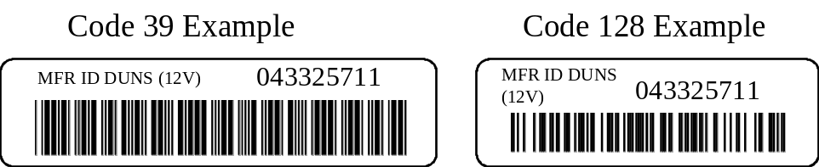

(1P) = ASC MH10 ‘DI’ immediately followed by (MH80312) = Manufacturer’s Product Number
Figure G-1 Example – Using DUNS Number in Bar Codes
See Figure G-2 for an example using Code 39 or Code 128 to identify the manufacturer & the product number in one combined bar code symbol.

(9P) = ASC MH10 ‘DI’ immediately followed by the 9-digit DUNS (043325711) plus Mfr’s. Product Number (MH80312)
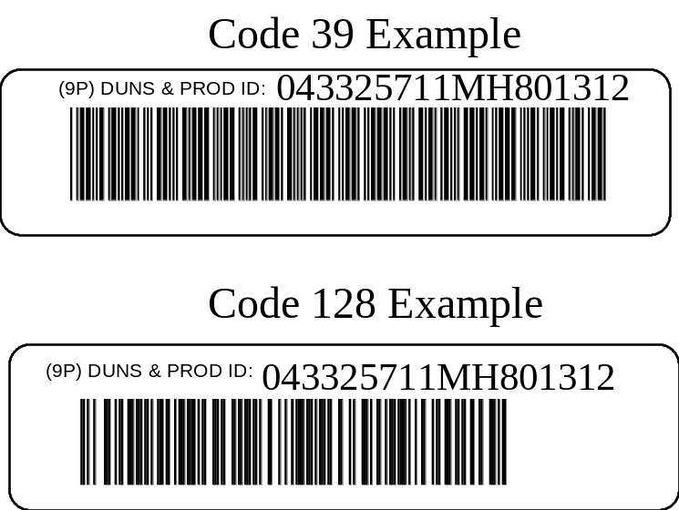
Figure G-2 Example – Using DUNS Number in Bar Codes

Using the DUNS Number in 2D Symbols

Figure G-3 shows a label including a Data Matrix symbol encoding DUNS and product ID, ‘Traceability Number’ (e.g., Serial number, Lot/Batch number, Manufacture Date), and Country of Origin.

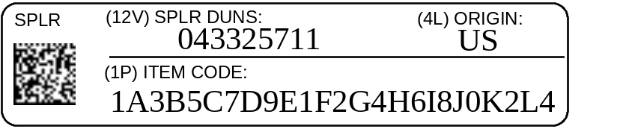
Figure G-3 Example – Using DUNS Number in 2D Symbols

(Informative, Not Part of Standard)
Serialization of some electronics products

Cellular Mobile Telephone (CMT) Electronic Serial Number
The standard recognizes the need for an electronic serial number for manufacturers of the cellular mobile telephone (CMT). The CMT has two (2) serial numbers; namely an item serial number (MSN) assigned by the manufacturer, and an electronic serial number (ESN) that is controlled by the Federal Communications Commission (FCC) in the USA.

CMT Electronic Serial Number Derivation
In the USA, the FCC assigns the first three characters of the ESN to the CMT manufacturer. The manufacturer then assigns the last five characters of the ESN. These eight characters are hexadecimal, meaning that each character can have one of sixteen values (0-9 and A-F). Some manufacturers convert this 8 character hexadecimal number into an 11-digit decimal number. This standard supports ESN length of up to 20 alphanumeric characters.

CMT Electronic Serial Number Bar Code Symbol Title
The title should be "CMT Electronic Serial Number." The suggested GS1-128 printing format is shown on Exhibit H-2. The title should be printed above the bar code.

If a Data Identifier is used for the electronic serial number, the title should be “(22S) CMT Electronic Serial Number”. (See H.1.3)

CMT Electronic Serial Number Identifiers
The GS1 Application Identifier 8002 has been assigned to the Electronic Serial Number (ESN). Therefore, when encoding the ESN in GS1-128 symbology, the numbers 8002 shall precede the eight or eleven character ESN. When representing this encoded data in human readable form, the AI 8002 shall be enclosed in parentheses and precede the ESN. However, the parentheses shall not be considered part of the data; therefore, the parentheses shall not be encoded in the bar code nor key entered, should keying of the bar code data be necessary. See Exhibit H-2.

If Code 39 or Code 128 is used for CMT electronic serial number, the CMT electronic serial number shall be preceded by 22S in keeping with ANS MH10.8.2. The Data Identifier is not shown as part of the human readable bar code interpretation; rather it is enclosed in parenthesis and printed in the bar code title. (See H.1.2)

CMT Electronic Serial Number Label Placement and Orientation
The CMT electronic serial number bar code symbol shall be combined with the item serial bar code symbol and the point-of-sale bar code symbol, as shown on Exhibit H-2, to form a label. Due to the number of bar code symbols involved and the limited space available on some CMT components, it may not be possible to stack the bar codes one over the other. Figure H-4 on Exhibit H-2 shows a modified vertical/horizontal bar code orientation, which may be necessary to help with label placement and orientation.

When using the modified vertical/horizontal bar code orientation shown in Figure H-4 on Exhibit H-2, care must be taken to separate the EAN/UPC symbol's quiet zone from the serial number bar code symbols' quiet zones. The EAN/UPC symbol should be centered vertically between the two serial number bar codes, and the two serial number bar codes should be vertically separated by 12.7 mm (.5 in).

Interior Service Number
This Standard recognizes the need for an interior service number or secondary serial number to assist in the verification and authentication of processing warranty claims for some electronics products. The interior service number should be different from the item serial number shown on the outside of the equipment/product. The interior service number should not be visible unless the cover of the equipment/ product is removed. The use of an interior service number is at the discretion of the manufacturer.

Interior Service Number Derivation
The interior service number or secondary serial numbers derived from the item serial number, and should be encrypted by any manufacturer in a manner that is unique to that manufacturer and of that manufacturer's choosing. This standard recommends the use of a "check character algorithm" to create an interior service number from an item serial number. In other words, the item serial number will be contained within the interior service number. However, the interior service number will be one character longer with a calculated additional character in the right-most position.

If alpha characters are used in an item serial number, a Mod 36 "check character" calculation would be required (See Annex I). If alpha characters are not used in the manufacturer's serial number, a Mod 10 "check character" calculation could be used, similar to that used with the UPC-A symbol. Different position weighting schemes could be used to further "complicate"/encrypt the calculation, regardless of whether the Mod 36 or Mod 10 calculation is used. See Exhibit H-1 for an example of a Mod 10 algorithm used to derive an interior service number. See Annex A for Mod 36 calculations.

Each manufacturer may choose its own scheme for interior service numbering and calculating the rightmost "check character." Likewise, each manufacturer may choose a scheme that does not use the "check character" calculation. If a secondary serial number is used for the purpose of providing an interior service number, it shall be preceded with the appropriate application or data identifier.

NOTE: The Interior Service Number check character is not the symbology check character that is used to verify correct reading of the bar code symbol. The Interior Service Number check character is part of the data that is encoded and displayed in the human readable interpretation.

Interior Service Number Bar Code Symbol Title
The title should be "Interior Service Number." The suggested printing format per the GS1 General Specification is shown on Exhibit H-1. The title should be printed above the bar code.

If a Data Identifier is used for the interior service number, the title should be “(30S) Interior Service Number”. (See H.1.3)

Interior Service Number Identifiers
Since the interior service number or secondary serial number bar code application is different from the item serial number application, a different GS1 Application Identifier (AI) from the AI 21 is needed. The GS1 AI assigned for a secondary serial number or interior service number is AI 250. Since the item serial number can contain up to 20 alphanumeric characters, this interior service number must be able to contain up to 21 alphanumeric characters. For this bar code application to be successful, the data system must be able to capture, contain and print the "check character" calculated and placed in the right most position, hence the need for a 21-character field length.

When using the GS1-128 symbology, the interior service number shall be preceded by the numerals 250 in keeping with the General GS1 Specifications. When this secondary serial number and Application Identifier (AI) are represented in human readable form, the AI shall be shown in the human readable interpretation of the bar code symbol, separated from the rest of the data by parentheses. However, the parentheses shall not be considered part of the data; therefore, the parentheses shall not be encoded in the bar code nor key entered, should keying of the bar code data be necessary. (See Exhibit H-2, Figure H-4.)

If Code 39 or Code 128 is used for the interior service number, the interior service number or secondary serial number shall be preceded by the numerals 30S in keeping with ANS MH10.8.2. The Data Identifier is not shown as part of the human readable bar code interpretation; rather it is enclosed in parenthesis and printed in the bar code title. (See H.1.2)

Interior Service Number Label Placement and Orientation
The interior service number or secondary serial number bar code symbol should be printed, along with the point of sale bar code symbol, as shown in Exhibit H-1, Figure H-2, to form a label. This label should be placed inside the product so that it is not visible without removing the case or cover. Each manufacturer must decide on its own where the most appropriate placement and orientation should be for each product that utilizes the interior service number.

Data Identifier | Data Field | Data characteristics  Type followed by the number of characters e.g., a#, n#, an#)* | Description
22S | Cellular Mobile Telephone (CMT) Electronic Serial Number | n3+an...25 | Electronic Serial Number (ESN) for Cellular Mobile Telephones or the Mobile Equipment Identifier (MEID).*
30S | Secondary serial number/Interior service number | an3+an...21 | Secondary serial number or interior service number of a component of a trade item**

Application Identifier | Data Field | Data characteristics  Type followed by the number of characters e.g., a#, n#, an#)* | Description
250 | Secondary serial number/Interior service number | n3+an...30 | Secondary serial number or interior service number of a component of a trade item^{Note}
*See ESN Assignment Guidelines and Procedures and MOBILE EQUIPMENT IDENTIFIER (MEID) GHA (Global Hexadecimal Administrator) Assignment Guidelines and Procedures for additional information on ESN and MEID.
**If this AI “250” is being used a trade item must be symbol marked with the following Element Strings:
- AI 01 representing the identification number (GTIN) of the trade item
- AI 21 representing the serial number of the trade item
Table H-1 Data and Application Identifiers used for the Electronic Serial Number and the Interior Service Number

EXHIBIT H-1
Figure H-1
Item Serial Number Bar Code Label

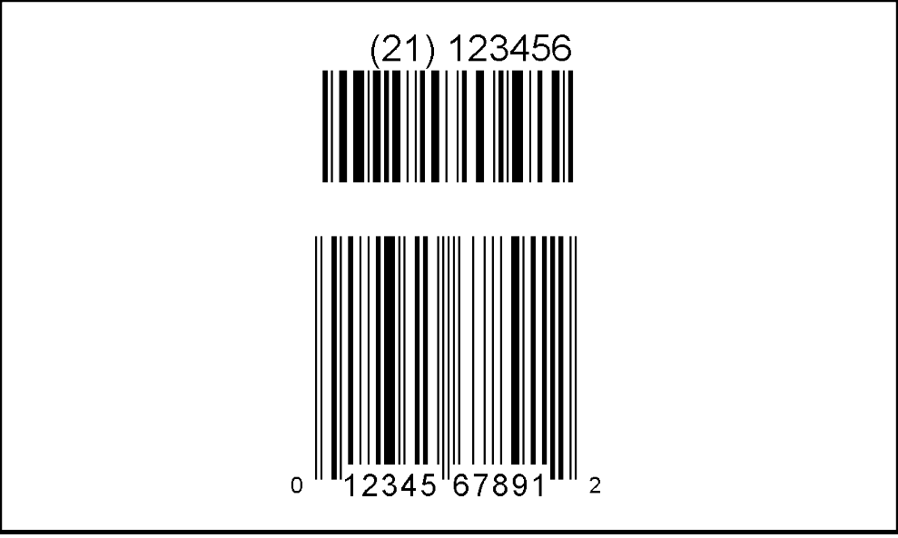
Item Serial
Number
b
c
d
e
f
a

Figure H-2
Interior Service Number Bar Code Label

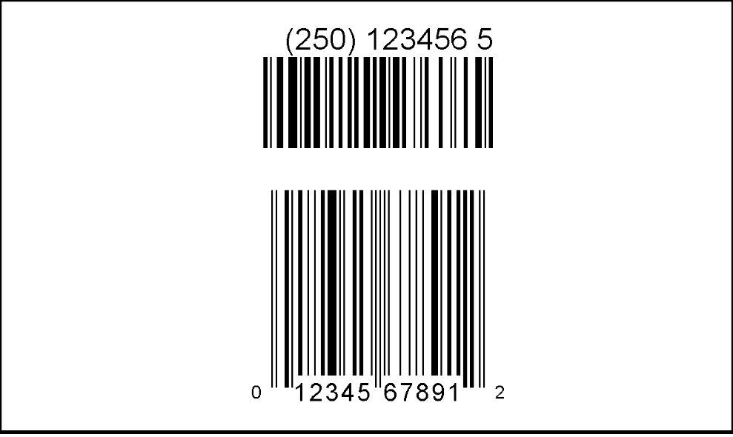
Interior Service
Number
b
c
d
e
f
a

Label Specifications

b
c
a
The overall height of the label should be a
minimum of 60.9 mm (2.4 in).
The two line human readable title information
should be a minimum height of 6.4 mm (0.25 in).
The human readable encodation height should
be a minimum of 4.8 mm (0.19 in).
e
f
d
The overall height of the UCC/EANGS1-128 bar
code should be a minimum of 12.7 mm (0.5 in).
The distance dividing the UCC/EANGS1-128 and the
Point-of-sale bar code should be a minimum height of
3.2 mm (0.13 in).
The overall height of the point-of-sale bar code
should be a minimum of 25.9 mm (1.02 in).

NOTE: There should be a minimum of 6.4 mm (0.25 in) margin between the edge of the label and the information included in the label (including bar code quiet zones).

EXHIBIT H-2

Figure H-3
CMT Vertical Label

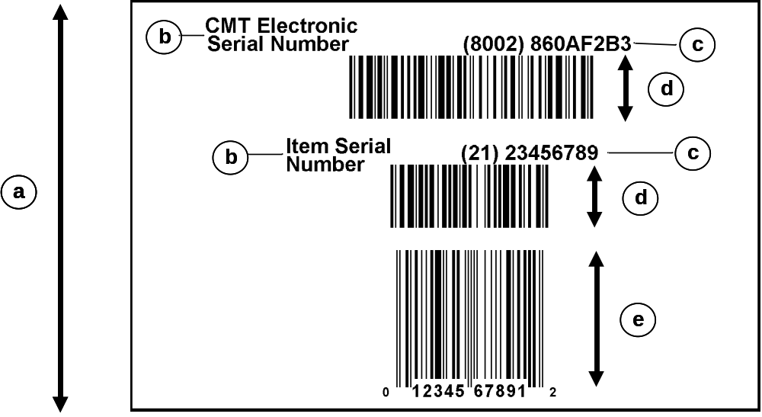
Figure H-4
CMT Modified Vertical /Horizontal Label

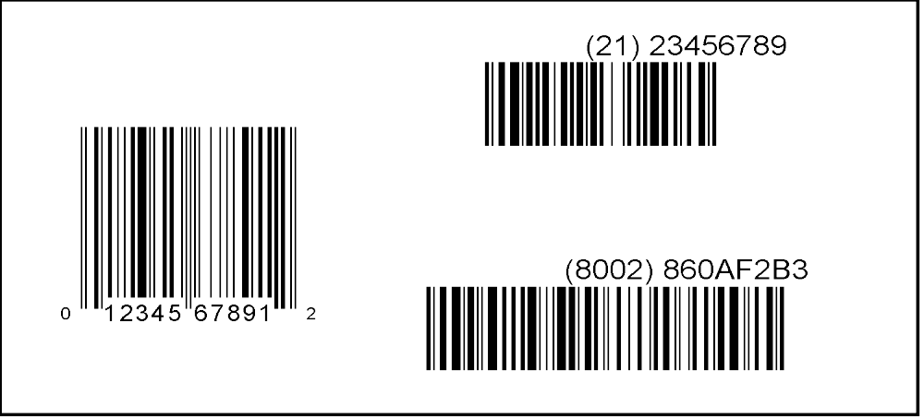
Item Serial
Number
b
c
d
e
f
a
d
CMT Electronic
Serial Number
Label Specifications

b
c
a
The overall height of the label should be a minimum of 82.6 mm (3.25 in) for Figure 1, and
63.5 mm (2.5 in) for Figure 2
The two lines of human readable title information should be a minimum height of 6.4 mm (0.25 in).
The human readable encodation height should be a minimum of 4.8 mm (0.19 in).
e
f
d
The overall height of the UCC/EANGS1-128 bar code should be a minimum of 12.7 mm (0.5 in).
The overall height of the point-of-sale bar code should be a minimum of 25.9 mm (1.02 in).
The quiet zone before and after all bar codes should be a minimum of 6.4 mm (0.25 in).

NOTE: There should be a minimum of 6.4 mm (0.25 in) margin between the edge of the label and the information included in the label (including bar code quiet zones).

EXHIBIT H-3
Calculating a typical Interior Service Number from an all numeric Item Serial Number using a Mod-10 check character algorithm:


Item Serial
Number
12.7 mm (0.5 in)

IMPORTANT: Character positions are numbered from RIGHT to LEFT in this algorithm with the check character in the first (rightmost) position. (See Annex E.)

The item serial number application identifier shall not be included in the check character calculation.

EXAMPLE: Assume an item serial number of (21) 123456 as shown above.

(21) 123456

Position 1 reserved for check character

Step 1: |  | 2 + 4 + 6 (from right) | = 12
Step 2: |  | x 3 | = 36
Step 3: |  | 1 + 3 + 5 (from right) | = 9
Step 4: |  | 36 (Step 2) + 9 (Step 3) | = 45
Step 5: |  | 45/10 = 4 with a Remainder of 5; 10 - 5 | = 5 (check character)

The resulting interior service number would be:

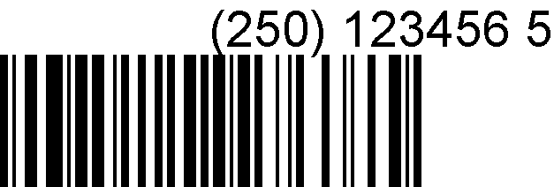
Interior Service
Number
12.7 mm (0.5 in)

NOTE: (250) is the Interior Service Number Application Identifier and "5" in the rightmost position is the calculated "check character" value.

(Informative, Not Part of Standard)
MOD 36 Interior Service Number "Check Character" Calculation

A "check character" algorithm is suggested to calculate the interior service number or secondary serial number from the manufacturer's serial number. The Mod 36 check character (remainder method) should be used if alpha characters are contained in the item serial number. This "check character" is neither a replacement for nor the same as any symbology check character(s).

TABLE I-1
CHARACTER VALUE TABLE

Value Character Value Character

0 0 18 I
1 1 19 J
2 2 20 K
3 3 21 L
4 4 22 M
5 5 23 N
6 6 24 O
7 7 25 P
8 8 26 Q
9 9 27 R
10 A 28 S
11 B 29 T
12 C 30 U
13 D 31 V
14 E 32 W
15 F 33 X
16 G 34 Y
17 H 35 Z

TO CALCULATE THE MOD 36 CHECK CHARACTER (Remainder Method):

Data Content (For Check Character Calculation)

The interior service number or secondary serial number application identifier (AI) is 250. The interior service number application identifier shall not be included in the check character calculation.

The item serial number application identifier shall not be included in the check character calculation.

IMPORTANT: Character positions are numbered from RIGHT to LEFT in this algorithm (the check character is in the first position).

Step 1: |  | Starting from position 2 of the number (i.e., the character to the left of the position reserved for the check character), add up the values of the characters in even-numbered positions.
Step 2: |  | Multiply the sum obtained in Step 1 by 3
Step 3: |  | Starting from position 3 (from right) add up the values of the characters in odd-numbered positions.
Step 4: |  | Add the product of Step 2 to the sum of Step 3.
Step 5: |  | Divide the sum of Step 4 by 36. Look in the Character Value Table for the character with the remainder value. This corresponding character is the Mod 36 check character, and it becomes the right-most character in the interior service number.

EXAMPLE

Assume the item serial number of:

(21) 1 A B C 4 5 6 7 8 9 D 1 F 2 G 3

Position 1 is reserved for check character

Step 1: |  | 10 + 12 + 5 + 7 + 9 + 1 + 2 + 3 (from right) | = 49
Step 2: |  | x 3 | = 147
Step 3: |  | 1 + 11 + 4 + 6 + 8 + 13 + 15 + 16 (from right) | = 74
Step 4: |  | 147 (Step 2) + 74 (Step 3) | = 221
Step 5: |  | 221/36 = 6 with a Remainder of 5

Looking in the value Table, a remainder value of 5 corresponds to a character of 5; therefore, for this example, the check character is 5.

The final interior service number for this example is:

(250) 1ABC456789D1F2G3 5

Mod 36 Check Character

Item Serial Number

Interior Service Number AI

NOTE: If Step 5 results in a remainder of zero, the check character is zero. If the remainder is greater than nine, the check character is an alpha character.

